La Moye School

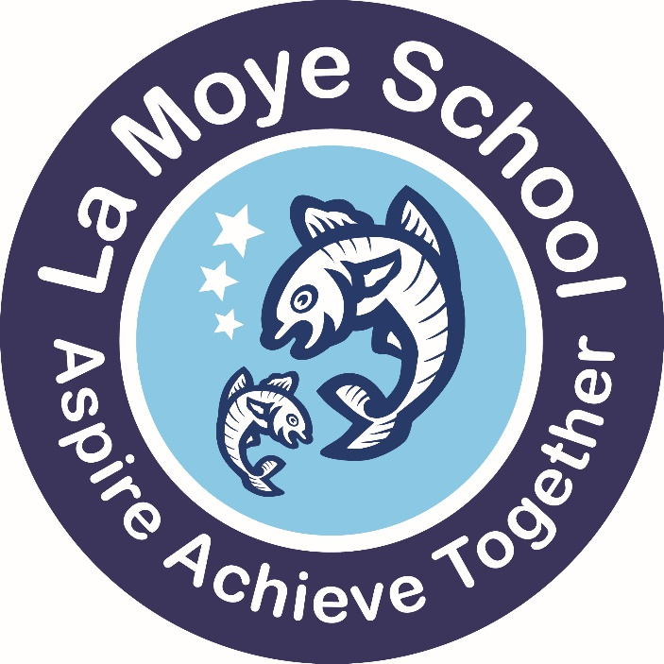
School Handbook 2023/2024
www.lamoye.sch.je
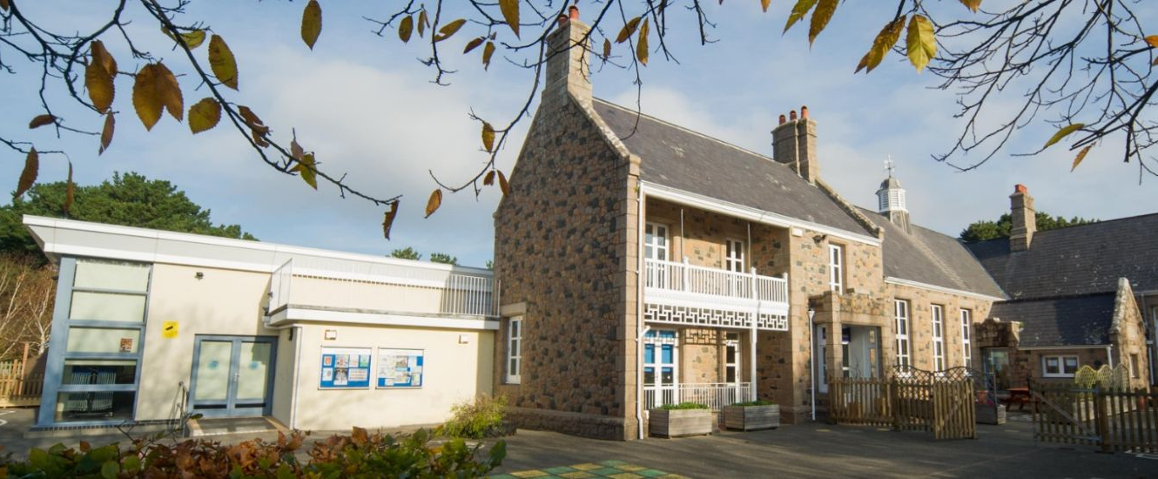

Contents
 | Page
Welcome Message | 2
Core Values | 5
Rights Respecting Schools  Admissions Policy | 8  8
Times of the School Day | 9
Staffing | 10
Healthy Eating | 11
School Uniform and Pupil Appearance | 12
Parental Involvement and Communication and Absence | 14
Health and Medical Information | 16
Keeping Healthy | 19
Visiting the School, Parking and Cycling  Eco School, Clubs & Extended Curriculum  Home Learning | 19  20  21
Curriculum and Learning

Assessment and Reporting | 23
Special Educational Needs | 24
English | 25
Mathematics | 28
P.S.H.E. | 29
Science | 30
IT | 31
Wider Curriculum | 32
French | 33
Art and Design | 34
Music | 36
P.E. | 37
R.E., Collective Worship | 39


Headteacher’s Welcome
Pupils and learning are at the centre of all that we do:
La Moye School is a high performing, inclusive school in the Parish of St. Brelade. We have wonderful, friendly and motivated pupils, a dedicated and hard-working staff team, a committed P.T.A, supportive parents, and excellent facilities - including a great outdoor environment.
The school was recently reviewed as part of the Jersey Schools Review Framework, and the report can be viewed on our school website and the www.gov.je website. We are delighted with this positive report, the recognition of our staff’s shared sense of purpose and commitment, and the positive impact this has on our pupil’s happiness and success. This highlights the positive journey of development the school has been on. We are using the recommendations to support our next steps, as we fulfil our school mission, to do the best for every pupil, within our culture of mutual respect and care.
About us:
La Moye is a two form entry primary school (two classes per year group) with fifteen classes in total, including a Nursery unit. There are approximately 360 pupils spread throughout the school from Nursery to Year 6, with our Nursery unit having up to 30 places for children from the age of 3. We are the largest school in the West of the Island and serve a far-reaching catchment area to the North and West of St. Brelade. We also, due to our size, often take pupils from outside of the catchment area.
We are an inclusive school and have a comprehensive intake. The staff team work hard to get to know and support the needs of every child, working in close partnership with families, and where necessary, other agencies.
A safe and stimulating environment that promotes positive wellbeing and learning:
The school is set in beautiful surroundings, with plenty of space for the pupils to play and many opportunities for learning outdoors. There are a variety of play areas, an adventure playground and a woodland area, as well as an all-weather school field. We believe learning outdoors offers many fantastic opportunities and try to make the best use of our grounds, the local area and Jersey as a whole through our rich curriculum offer. Pupils also are able to participate in a wide range of educational visits both in Jersey and off island, to Sark in Year 2 and when possible, France in Year 6. We also welcome visitors into school that support our learning and education programmes.
Our aim is to prepare pupils for the next stage of education as well as for life; as such, digital learning skills are taught to all pupils. Computing is well resourced and used naturally and regularly to support learning through the use of laptops, iPads and other devices. Pupil’s have many opportunities to contribute to the running of our school. Our active School Council guides us in selecting the charities that we support, and these events are highly successful. Our Eco Team monitor the school’s approach to recycling and waste, and ensure we promote sustainability. We train older pupils to support younger pupils through the Young Interpreters programme and as Peer Mediators, which are both very successful and well regarded by the pupils.

Our sports teams do very well in Island events and tournaments such as cross-country, football, netball and tag rugby. Pupils have the opportunity to work towards representing the school in a number of disciplines and we encourage the development of sporting as well as artistic, musical and other talents. Traditionally the school performs well in the Eisteddfod and other competitions; everything from growing vegetables and arts and crafts, to performance poetry, French, handwriting and Jerriais. The school runs a wide range of lunchtime and afterschool clubs and activities as well as a Breakfast Club to support working parents.

Aiming for constant improvement so we can be the best we can be:
La Moye is a ‘learning’ school we work with other schools in Jersey and beyond, and draw on the latest research to support and challenge our practice. We share our school improvement focuses with parents to provide an understanding of what we are working on each year. You can find our latest Strategic Plan 2022-2025 and School Improvement Plan on our school website.
We encourage a positive ethos, and value everyone’s contribution and expertise. We provide our staff with a comprehensive programme of professional development to extend their knowledge, understanding and skills. We use mentoring and coaching to building on strengths and talents, towards the highest standards of teaching.
Relationships are at the heart of all that we do:
We pride ourselves on having an ‘open door’ policy. Working in partnership with families we can achieve the best outcomes for pupils. Parents have many opportunities to come and share learning with their children and we in turn keep everyone informed of progress, attainment and targets through regular meetings and reports.

Our Parent Teacher’s Association (PTA) raises a significant amount of funding for the benefit of La Moye pupils. They host events such as regular school discos, movie nights, bingo and fairs. All parents are automatically part of the PTA and the team are always looking for new members and support, and welcome new ideas too. You can contact them through their Facebook page, https://www.facebook.com/LaMoyeSchoolPTA/.

If you ever have any questions or concerns, please do not hesitate to contact us. It is vital that we work together in partnership, and work collaboratively, for the benefit of your child.

Our school website (www.lamoye.sch.je) and our Facebook page: https://www.facebook.com/www.lamoyeschool.co.uk/ provide a lot of information about the school so do make good use of these.

We look forward to welcoming you and your family to La Moye!
Mission and Core Values
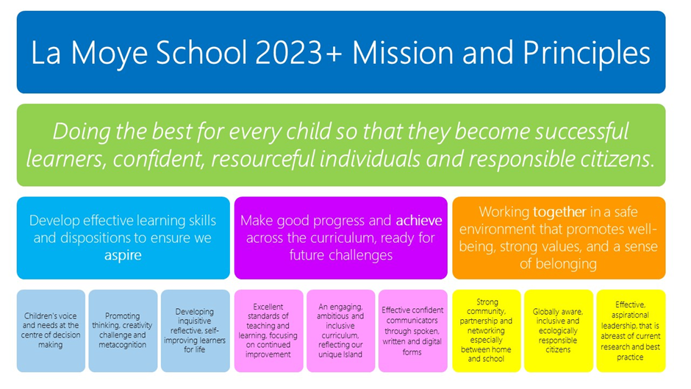
Our Core Values: Aspire, Achieve, Together guide our school’s development and underpin our ethos. When we wrote out values, we involved our whole community- staff, parents and pupils.
We teach our pupils about our Core Values from Nursery and our reward system, our policies and the way we work each day reflects these values.
At the centre of our school is the firm belief that everyone in our community – pupils, teachers, parents/carers & visitors – share a responsibility for the learning, wellbeing, safety & enjoyment of everyone at our school through these Core Values.

What does this mean?
Aspire | - We believe in every child and have high expectations of them all.  - We teach pupils to aspire and be determined to succeed and improve.
Resilient: | Life is full of challenges! We all need to learn to bounce back when we meet challenges. Learning new skills and knowledge can be tricky at times, and it is sometimes tempting to give up.  Therefore we promote a ‘growth mind-set’ where pupils realise practice and determination are key to success. We teach strategies to enable pupils to have the resources to draw on when they are finding things tricky.
Motivated: | Often the most successful people are those that work hard, try their best and put in lots of effort. It is about working hard on what you are good at, and even harder on those things you find less easy.  Therefore we praise motivation and perseverance and encourage pupils to try hard, and produce their best so they make the best possible progress.
Creative: | Seeing things differently and thinking in new and innovative ways with a questioning mind is vital in a rapidly changing world. The world we live in today will be very different to the world of the future. Every new invention has needed someone with a creative mind to think it up!  Therefore we promote and develop creative approaches to learning, and encourage pupils to think for themselves and ask questions.
Achieve | - Every child should achieve and progress to become the best they can be.  - We teach pupils to strive for success and feel pride in their achievements.
Pride: | We are often proudest of those things that were hardest to achieve. When we feel proud of ourselves and our accomplishments we build self-esteem and confidence.  Therefore we use positive, precise feedback to promote pride, and we celebrate pupils’ achievements. We encourage pupils to take pride in the school and its surroundings and look after our resources, their belongings and the natural world.
Progress: | Progress should be a given in our school. Our expectation is that pupils will make good progress over time, and that every child will feel the achievement that ‘getting better at something’ provides.  Therefore we plan to ensure pupils make progress in lessons, through providing both support and challenge for learners. We encourage pupils to recognise their own and other people’s progress, and that even small steps of progress ought to be celebrated.
Success: | Some successes are large, some are small, but having success with what you are working on or learning boosts confidence and builds aspiration.  Therefore we plan to ensure pupils achieve successes in lessons and we celebrate and acknowledge successes, academically and in all aspects of pupils’ development.
Together | - We believe developing a strong sense of community is vital to pupils’ development as future Jersey citizens.  - We teach pupils to work together in groups, teams and as a school, and plan events that bring our community together.
Care: | We care. First and foremost, we care about each and every child that we teach, but we also strive to work with their families closely too.  Therefore we teach pupils to empathise, look after and support each other, but also care and value themselves as unique individuals.
Respect: | Each one of us is different and our school is made up of pupils from a range of cultural, religious and ethnic backgrounds. By respecting people’s differences we will be able to focus on how similar we all really are and work together positively.  Therefore we teach pupils to accept and respect differences, and to respect each other. We do not tolerate bullying or discrimination, and teach pupils to develop inclusive attitudes.
Trust: | Trust is hard to gain, and easy to lose. Trust relies on clarity, honesty, integrity and openness. Once trust is established it is much easier to work together collaboratively, to allow greater freedoms and to promote independence.  Therefore we aim to be honest and open in our dealings with pupils and parents. We aim to build trusting relationships with pupils and their families through clear communication and open dialogue. This enables us to work together effectively with the ‘child at the centre’.



At La Moye Primary School, we aim to be a school where children’s rights are at the heart of our ethos and culture, to improve well-being and to develop every child’s talents and abilities to their full potential. We are a ‘Rights Respecting School’, an award given to schools on behalf of Unicef UK. We are currently at ‘silver’ level for this and are now working towards our ‘gold’ award.
Unicef is the world’s leading organisation working for children and young people and their rights. In 1989, Governments across the World agreed that all children have the same rights by adopting the UN Convention on the Rights of the Child (UNCRC). These rights are based on what a child needs to survive, grow, participate and fulfil their potential.
La Moye School pupils will learn about their rights by putting them into practice every day. A Rights Respecting School models rights and respect in all its relationships.
For further information about Rights Respecting Schools and the Convention on the Rights of the Child please visit: www.unicef.org.uk/rrsa and unicef.org.uk/crc.
Admission Policy and Transition
Pupils are admitted to the Reception classes according to Education Department Policy:
“All pupils whose fifth birthday falls between 1st September and 31st August are entitled to commence school on a full-time basis during September of the Autumn Term.”

In order to support transition, we work in close liaison with the local nurseries / playgroups and reciprocal visits are made when possible. Pupils are invited into school for sessions in the term before they start school to meet the teachers and become familiar with the classroom.
If your child will be joining us in Nursery or Reception, then you will be invited to a welcome evening where you can meet the staff and find out more about the school. After this, there will be a planned series of meetings and events to support transition, such as home visits, 1:1 teacher meetings and a number of pop in sessions where your child can come and visit their new classroom, often with parents too. Some children need more than this, and so bespoke transition is offered to support children with additional needs.
If your child is joining us at another point in their school career, then you will be invited to look around the school and meet key staff at a mutually convenient time.
If you ever have any concerns or questions about your child’s transition, do let us know.
The School Day
 | Nursery | Reception | KS1 & KS2
 | Doors open at 8:30 a.m. and teachers are on duty in the classrooms.
Morning | 8:45 – 12:30 | 8:45 – 12:00 | 8:45 – 12:00
Afternoon | 12:45-2:45 | 1:00 – 2:55 | 1:00 – 3:00

Before & After School
Members of staff are on duty 15 minutes before and after each school session. We operate a ‘soft start’ to the day whereby pupils are encouraged to arrive at school from 8.30am onwards with the aim of being ready for the formal start of the day at 8.45am. Please note that pupils should not arrive at school before 8:30am unless they are attending Breakfast Club as detailed below. The school cannot accept responsibility for pupils arriving before 8.30 am or remaining on the premises after 3.15pm unless taking part in a supervised activity. If pupils are found in the playground unsupervised before 8.25am they will be taken into Breakfast Club and parents will be charged for the session. All pupils must be in school by 8:45am or they will be recorded as ‘late’.

Breakfast Club
Breakfast Club operates each morning from 7:30 am – 8:30 am and is available for children Reception through to Year 6. Pupils should be brought to the Breakfast Club entrance (currently the hall), where they will sign in and be supervised by a member of staff. Food is not currently provided at Breakfast Club. Pupils take part in a range of supervised in activities before school. Current charges are as follows (these charges are reviewed on a regular basis):
- £2.50 per day (payable in advance for the half term or term);
NB: There are limited places available at Breakfast Club. All enquiries should be made in the first instance to the school office.
Mini-Me’s also offer a wraparound care facility at Communicare before and after school which parents may wish to explore. They drop children to and from school by minibus.

Breaks
Years 1 - 3 usually have a break between 10:00 am– 10:15 am. Years 4 – 6 usually have a break between 10.30 am -10.45 a.m. Foundation Stage pupils choose when to have their own snack and have access to a supervised play area outside. In line with our healthy eating policy Years 1-6 are only allowed fruit and vegetables and water for snack. Juice and other food items are only for lunchtimes.

Lunchtime Supervision
Behaviour at lunchtime is monitored closely and the school expects, and indeed enjoys, high standards of behaviour. The Headteacher reserves the right to exclude pupils during the lunch period if their behaviour poses a threat to the health and safety of others or they fail to maintain the expected standards. In such a case, parents will be asked to make alternative arrangements for the lunch period.
Staff Team
Senior Leadership Team

Mr J Baudains  Mr L Gibaut  Mr M Steigenberger  Mrs S Nolan  Mrs L Boyle  Mrs H Le Couilliard  Phase Leaders  TBC  TBC  TBC  TBC | Headteacher  Deputy Headteacher  Assistant Headteacher  Senior Teacher  Business Manager  Special Educational Needs and Disabilities Co-ordinator (SENDCo)  Early Years Phase Lead (Nursery and Reception)  Lower Phase Lead (Year 1 and 2)  Middle Phase Lead (Year 3 and 4)  Upper Phase Lead (Year 5 and 6)
Class Teachers  Mr M Steigenberger  Mrs G Sohna  Miss C Wellman  Mrs M James  Mrs S Price-Bramble  Mrs S Nolan  Mrs R Reed  Mrs H Dupre  Mrs K Barcis  Miss J Morris  Miss N Carter  Mrs L Watts  Mrs A Betts  Miss H Trigg  Miss M Minty  Mrs G Stas | Specialist Subject teachers & Cover Teachers  Miss N Le Miere  Mr D Murphy  Mrs S Baker  Miss L Lopez  Mrs N Brown  Mrs A Richardson |  | Support Staff  Mrs A Bond  Mrs M Paine  Mrs A Bentley  Mrs N Butler  Mrs P Wallace-Sims  Miss M Ward  Miss C Foott  Mrs K Aked  Mrs G O’Brien  Mrs. C Grigg  Mrs S Lopez-Rubio  Ms S Stokes  Ms S Romeril  Miss L Raynor | ELSA/Wellbeing  ELSA/Wellbeing  Reception T.A.  Reception T.A.  Nursery Officer
Mrs T Cameron  Mr D Thomas | School Receptionist  Caretaker | Mrs A Bloomfield  Miss S Dave |  | Lunchtime Supervisors

Healthy Eating
Food and Health
We encourage the school and community to recognise the important connection between a healthy diet and a student’s ability to learn effectively and achieve high standards in school. We are a healthy school and actively encourage all pupils to be active and have a healthy diet. We also encourage pupils to drink plenty of water throughout the day. We are launching a new Health Eating policy in September 2023 to further improve this aspect of our school.
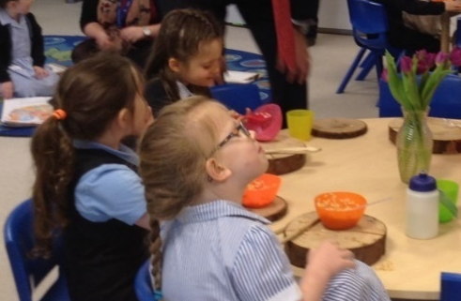
Snacks
Foundation Stage provide snack for their pupils during the morning session. A charge is made to parents towards the cost of snack provision.

Key Stage 1 and 2 Pupils bring in their own snack of fresh fruit and/or vegetables and water. No juices or other snack items are acceptable, unless a child has significant medical needs.

Lunch

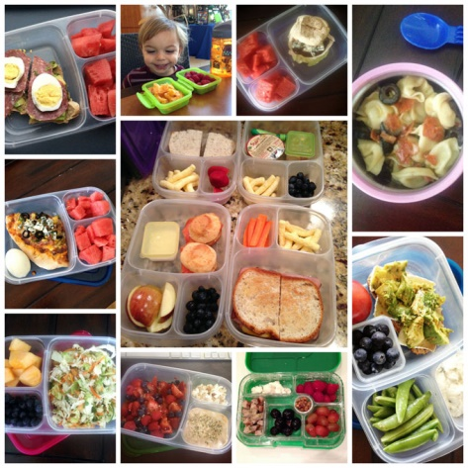
We encourage pupils to eat healthy food, e.g. fruit, cheese, raw vegetables. Lunch may consist of a sandwich or similar, fruit and or yoghurt, small biscuit or cake and a soft (non-fizzy) drink, such as water, milk or fruit juice. Please ensure your child’s lunch/snack box and water bottles are named.

For health reasons, we discourage too much heavily processed food and ask parents to limit ‘treat’ foods like crisps and pastries, and sweet treats like cakes, chocolate bars and biscuits. We recommend only one such item is included per day as a maximum- and ideally only rarely.

Nuts in any form are not permitted in school as a number of pupils and staff have severe allergies. We also need to be mindful of the other 14 most common allergens that can cause anaphylactic reactions, and we will update you if there is a need to raise awareness of any of these in your child’s class. Here is a useful link with more information: https://www.anaphylaxis.org.uk/about-anaphylaxis/14-major-food-allergens/

Birthdays and other Special Events
In order to celebrate children’s birthdays, we allow children to celebrate their individualism by wearing their own clothes. We do not encourage children to bring in sweets or cakes to give out to the class. However, if parents wish to send in a fresh fruit snack to give out, they would be welcome. If you are unsure about this, please talk to your child’s class teacher.

Water
All pupils have access to drinking water in their own water bottles in the classrooms.

What can you do to help?
A good breakfast in the morning before pupils come to school is an extremely important aspect of healthy nutrition and diet for your children. High quality sleep is very important too which is aided by having time before bed away from electronic screens.

Appearance
School Uniform
As a school, we encourage all our pupils to maintain high standards not only in their presentation but in their appearance too. There is an expectation that all pupils wear school uniform and look smart at all times. All logoed items can be bought from JSSK in Les Quennevais precinct. The PTA also stock good quality, second-hand uniform for sale. Other generic items can be purchased from a number of high street shops. Please note our uniform guidance is currently under review.
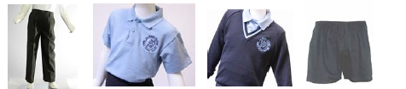
 | Option 1 | Option 2
Winter | Navy trousers  Light Blue polo shirt with school crest  Navy v-necked jumper with contrasting blue trim with school crest  Black Shoes (not trainers)  Black or Navy socks | Navy skirt, trousers or tailored shorts  Light Blue polo shirt with school crest  Navy v-necked jumper or cardigan with contrasting blue trim with school crest  Black shoes with sensible low heels  White/navy socks or navy tights
Summer | As above with the option of navy shorts in summer. | As above with option of La Moye School striped summer dress / navy shorts / blue/black sandals (not open-toed).
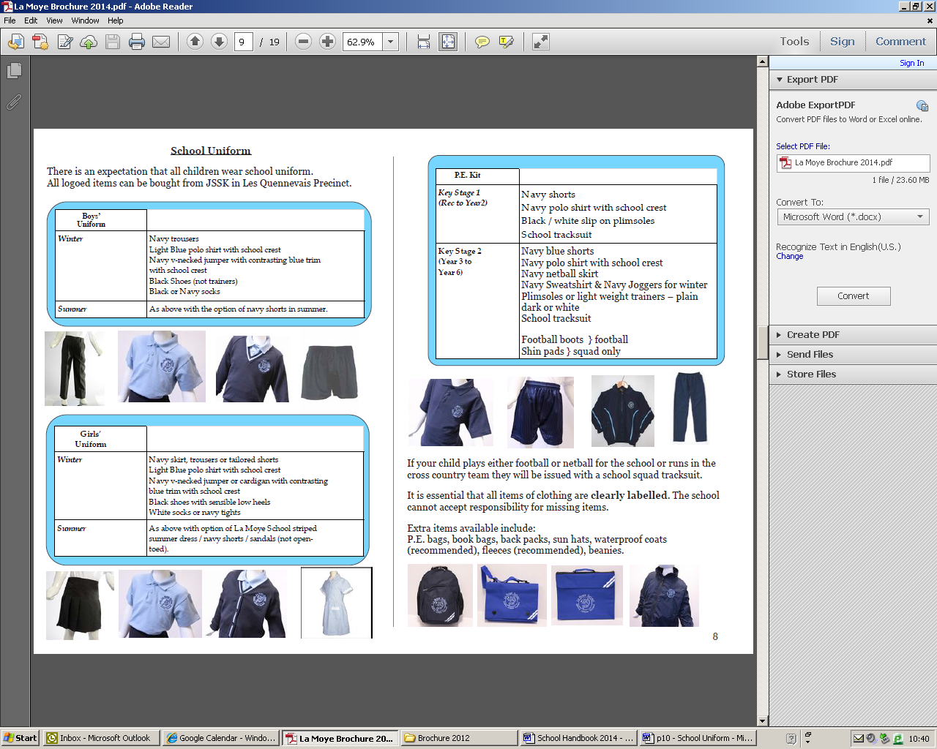
PE Kit
Key Stage 1 - (Rec to Year2) | Key Stage 2 - (Year 3 to Year 6)
Navy regulation shorts,  Navy polo shirt with school crest  Plimsolls or light weight trainers – plain dark or white  School regulation tracksuit | Navy regulation shorts or Navy netball skirt  Navy polo shirt with school crest  Plimsolls or light weight trainers – plain dark or white  School regulation tracksuit  Football boots & shin pads - football squad only
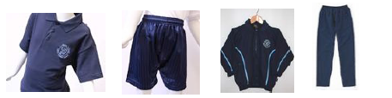

Pupils come to school in PE kit on the days they have PE if they have a school tracksuit (shorts are fine in the Summer). Pupils should not come to school in non-regulation track suits/leggings or skirts. If your child plays either football or netball for the school or runs in the cross country team they will be issued with a school squad tracksuit.

It is essential that all items of clothing are clearly labelled/named. The school cannot accept responsibility for missing items, please ensure any pre-loved uniform you have purchased has the correct name labelled.

Extra non-essential items available from JSSK include:
P.E. bags, book bags, back packs, sun hats, waterproof coats, fleeces and beanies.
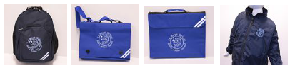
Hair
Any pupil with hair that is longer than shoulder length should have it tied back accordingly with a hair-band. This is for Health and Safety and working reasons.

Jewellery
The only jewellery permitted are a simple watch (not a smartwatch), and pupils with pierced ears may wear plain stud earrings. For safety’s sake these are removed or covered for P.E. If your child has had their ears pierced, only stud earrings should be worn. Nail varnish and other make-up items are not permitted.

Overalls and Aprons
Painting shirts or overalls are worn for messy activities. You may be asked to provide one of these.

Valuables & Personal Property
We actively discourage pupils from bringing valuable items and toys into school. However, if a pupil does so then we cannot accept responsibility for it if it gets broken or lost. Electronic items are not allowed unless specific permission has been given by a member of staff.

Mobile Phones and Smartwatches (inc. fitbits etc)
Any mobile phone brought to school must be, and remain, turned off during the school day and stored in the child’s bag. We do not allow pupils to wear smartwatches in school. Individual pupils are responsible for their own devices and the school cannot accept responsibility for these should they get broken or lost.

Lost Property
We have a lost property box which is situated in the corridor near the office area. Children are encouraged to look for lost items there. Please contact the school office if your child loses anything as we often seem to have a lot of unclaimed items.

Please make sure that all items of clothing, etc. are clearly marked with your child’s name. If items are marked they can easily be returned to their owner.

At the end of each half term, any unnamed items which are unclaimed will either be disposed of, given to charity or given to the second hand uniform shop for resale.

Parents and Communication

We pride ourselves on being an open, approachable school and welcome regular contact with parents.

Parental Involvement
Parents usually visit us when they are considering the school as potentially suitable for their child or when they have been allocated a place. These visits are an ideal opportunity for the Headteacher to discuss a child’s particular needs.

We welcome parents to accompany staff and students on outings, help with reading activities, cooking, sewing, painting etc. and generally assist the teacher(s). If you are available to help with any of these activities please contact the School Office.

There is a flourishing Parent Teachers Association of which, as a parent, you automatically become a member. Parents are encouraged to serve on the committee if they can. The aim of the PTA is to fund raise, provide social activities for the school and support the work of the school in curriculum activities. Through selfless effort this active group of people organise events that benefit the pupils’ education and enhance the warm community spirit within the school. Members of the PTA organise and supervise the annual Christmas parties and support the school discos for all pupils. Please visit the PTA Facebook page and check the PTA noticeboard in the playground for detailed information of what‘s going on and how to get involved.

Communication between Home and School
You will receive a half termly curriculum newsletter which will be sent to you via email. In addition, these newsletters and other information about school life can be accessed from the internet at http://www.lamoye.sch.je or our Facebook page, which is regularly updated.

Staff will also communicate with parents through reading and homework diaries and via e-mail. For any simple matter, do speak to the teachers after school. However, to discuss things properly, it is best to make an appointment to see the teacher at a mutually convenient time. We welcome constructive comments and staff are happy to arrange appointments to meet with parents. If you wish to speak to someone more senior, there is a Phase Leader responsible for each area of the school who will be happy to meet you. The Headteacher and Deputy Headteacher are also available for parents to discuss matters with, although an appointment will be necessary.

We hold formal parent consultation evenings during the Autumn and Spring term and in the Summer there is a pupil led consultation. All parents are given termly written reports detailing their child’s achievements in all subjects and their general progress and attitude.

Term Dates/InSet Days
Term dates vary slightly from year to year. However the dates are given out well in advance and are available on the link on the front page of the website http://www.lamoye.sch.je or on the www.gov.je website.

InSet Days are training days for teachers when the school is closed to pupils. These are set either by the school or by the Education Department. For 2023-2024 these dates are:

- Monday 4th September 2023
- Thursday 14th September 2023
- Monday 15th April 2024

Attendance at School
We are very proud of the high levels of attendance and punctuality achieved at our school. This has an enormous impact on the children’s focus and well-being at the start of each day and their progress throughout the year. We work with our Education Welfare Officer (EWO) to monitor attendance and punctuality and meet regularly to discuss this. Our EWO comes into school from time to time to meet parents and is always willing to talk to any parents with concerns.
Leave during Term Time
It is Department Policy that pupils should attend school, each day, throughout the defined school year, unless they are unwell. Every day a child is in school matters to their learning and progress. Term time dates are published at least a year in advance on the Education Department website (www.gov.je) to assist with planning holidays.

The Education Department does not, at any time, support leave during term time, however, in exceptional circumstances Headteachers have the discretionary power to grant leave in accordance with their Policy.

If you are forced to take your child out of school during term-time you must request leave of absence by completing an ‘Authorised Absence Request Form’ prior to any booking being made. This can be completed as an online form on our website or obtained from the School Office.
Any absence that is not covered under ‘Exceptional Circumstances’ will not be authorised and will be recorded as ‘unauthorised absence’ and may be followed up by our Education Welfare Officer.
Staff Absences
Staff are occasionally absent through illness or attending professional development courses. The School’s first priority is to ensure consistency for the children. Where possible the school will cover an absence with a supply teacher or by using our own staff. Where a supply teacher is unavailable, the school will ‘split’ the class to the other year groups with prepared work for the day or part of the day. Reception and Nursery classes are never split.

If for some reason there was a significant absence of a staff member, we will always write to you to explain the cover arrangements during this time.
Health
Medical Assessments
All pupils receive a medical assessment, including height and weight checks and hearing tests, from the School Nurse in their Reception year, together with a vision test by the Orthoptist. Further checks of growth are also carried out in Y6. The School Dental Service, with parental consent, carries out annual checks of the whole school.

Headlice
We would ask parents to ensure long hair is always tied back and regular scalp checks are made for headlice. This is a community problem and not just a school one. With regular inspection and combing, headlice do not pose a major problem. Combs are available to buy from local chemists.

Medication
We apply a strict Medication Policy following the Education Department guidelines. This means that we are only allowed to administer medication for long term treatments such as asthma/diabetes etc and prescribed medication such as antibiotics if they are prescribed more than 3 times per day. This is only allowed after parents have completed a consent form. It is the parents’ responsibility to ensure the School have up-to-date medication. Any medication should be brought to and collected from the school office by parents.

Please be aware that we use the playing field, woodland and Les Creux for walks and games and during the Summer months this can be a problem for hay fever sufferers. If your child is a sufferer, please administer any medication he/she may have for this condition each morning.

Parents should also be alert to children picking up ticks during the Spring and Summer. Guidance on how to remove ticks is available here: https://www.gov.je/Environment/LandMarineWildlife/Insects/pages/informationticks.aspx

Illness
If your child is unwell before the school day, please keep them at home. For safeguarding reasons, the School requires a telephone call/email when a child is off school for each day they are absent. In the interests of safeguarding, if no message is left, the School will contact parents/carers directly. We need to know what symotoms your child has because we have a responsibility to report some infections, and also alert staff, for example, if there is Chicken Pox in school. If no contact can be made then, the School must inform the Education Welfare Officer who will take further measures to ensure contact.
If your child has had diarrhoea or vomiting, they should not be brought back to school until at least 48 hours after they last vomited or had diarrhoea.

First Aiders
Most members of staff are trained in First Aid and every effort will be taken to ensure your child is treated appropriately should they become ill or hurt themselves. We keep an up-to-date medical log of all incidents. If it is felt that further treatment may be necessary, you will be contacted by School.

Any child who bangs their head will automatically have a note to take home informing parents/carers and be contacted by the School so that they can be monitored.

Fire Drills
Fire drills are held at least termly – including drills at lunchtimes. All pupils and staff have to know what to do and where to go in the event of a fire alarm. Our fire procedures and equipment are regularly inspected.

Safeguarding
Every child deserves to be happy and secure. Parents send their children to school each day with the expectation that school provides a secure environment in which their children can flourish. Parents and carers need to feel sure that the people in charge of their children within the school community are trustworthy, responsible and will do everything they can to keep their child safe from harm. La Moye School fully recognises its responsibility to safeguard and promote the welfare of all its pupils and to work together with other agencies to ensure adequate arrangements within our School to identify, assess, and support those pupils who are suffering harm. As a school we work in partnership with a range of other safeguarding agencies including the Children and Families Hub (CaFH), the Multi-Agency Safeguarding Hub (MASH), CAMHs, the Police and Social Services. More details can be found in our Child Protection and Safeguarding policies on our website.
It is vital for our safeguarding responsibilities, as well as our Data Protection responsibilities, that we have up-to-date contact details for all parents and carers.

Sign In/Sign Out
All visitors to the School are required to sign in and sign out using our electronic system in the reception area, and are given a visitor badge to identify them as an authorised visitor. This includes parents helping out at School.
If your child arrives at school after registration, perhaps due to a medical appointment, please use the iPad to sign them in. If you need to collect your children during school hours, please ensure your child is signed out on the iPad. We rely on this in the event of a Fire Alarm.
Digital Safeguarding
We take this extremely seriously. Children from Reception to Year 6 have a programme of lessons to develop their understanding of how to protect themselves when using computers and other devices that access the internet. We offer sessions for parents and provide information to keep you up-to-date about the most recent threats to children’s safety in the online world. For more information and useful resources, visit the www.thinkuknow.co.uk website which has information for children and parents.
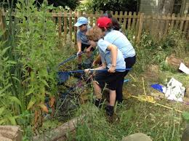
Sun Protection - In the Summer term and first half of the Autumn term, children must bring their own sun hats for use during breaks. When UV levels are high, sun cream is also necessary. Please apply all-day cream to your child as staff are not able to re-apply cream during the day.

Keeping Healthy
Wellbeing is important to the school. We have a wellbeing professional who visits weekly and members of staff (ELSAs) who takes support groups for various activities to support their wellbeing in school.
We also have visits from professionals such as the Educational Welfare Officer and Family Support Worker who can support any family where it is clear that there are circumstances affecting the wellbeing of the child. If any professional support is needed for a family, the school can refer them or provide the right contacts. Again, please let us know if home circumstances are likely to affect your child, we will always treat information confidentially but this helps us to work with you to support and care for your child.
Coming to and from School
Car Parking

Please use the car park at Les Creux Millennium Park, walking the pupils along the lovely country path and crossing opposite the School. We have a dedicated zebra crossing to facilitate this and we consider ourselves very fortunate to have such lovely spacious parking available. Please remind your children they must only cross the busy main road at the zebra crossing.

On no account should parents park in the roads at the rear of the School, or next door in the Links Halt Estate or at the local Morrisons shop. The local Parish authorities make regular checks of these areas and will book any car that is causing an obstruction or that is parked on property that does not belong to them.

We also ask parents to please respect the road markings in front of the School which is a strict no parking area. Only parent/carers whose child has their own disability badge are eligible to apply for a parking space in the car park in front of the School. We have a barrier system in place that controls entry and you will not be allowed entry without a permit.

Eco Active
Where possible we encourage pupils to walk, cycle or scoot to school and use the facility of the Railway Walk to the rear of the School.

No dogs are allowed onto any of the school grounds unless they are guide dogs. Do not enter through any school gate with your dog.

Walking Bus
We provide a free walking bus service for Years 1-4 children from Les Creux (Bowling Club) each morning, leaving at 8:35am, and returning from school at 3:10pm. This provides a useful service for parents/grandparents with limited mobility that would otherwise struggle with the walk to and from school. To access this service, please email the school office.

Year 5 & 6
Children in Years 5 & 6 are able, with parent/carer permission to make their own way home at the end of the school day.

Cycling to School
We are also fortunate that the Railway Walk can be used as a cycle path to and from school. There are some cycle racks in the area between the playground and the field – however no bikes should be left scattered around that area to prevent safe access to and from the field. We encourage all pupils to lock their bikes. All pupils must wear a suitable cycle helmet. The woodland path to and from the school to the Railway Walk is too narrow to cycle on, cyclings must dismount and walk their bikes.

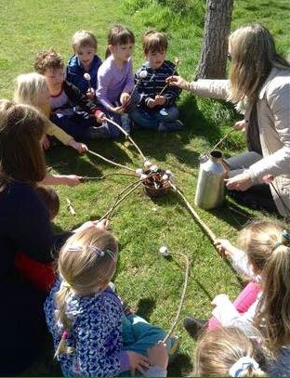
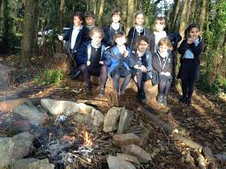
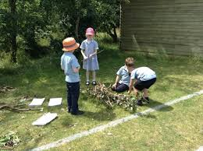
Eco-School
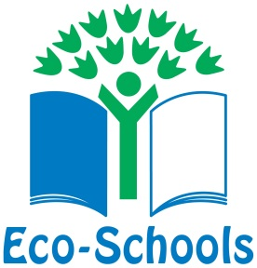
We are proud of being an accredited ’Green Flag’ eco-school and we make every effort to minimise our environmental impact through our actions and the choices that we make. We are currently working towards increasing the biodiversity of our school site and protecting our unique local marine environment. We encourage children to walk or cycle to school whenever possible; we monitor our energy usage and we aim to promote eco-friendly initiatives in both our everyday routines and in school events. We are signed up to the Plastic Free Jersey scheme and aim to minimise single use plastic waste across the school.
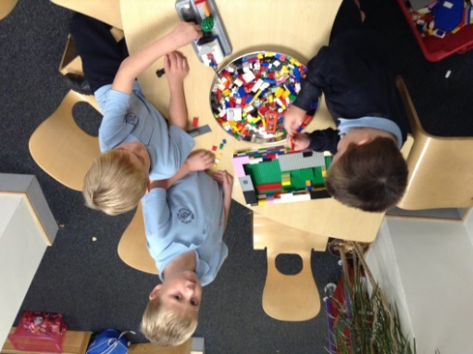
Our Eco Committee, leads our development; they meet regularly, liase with other schools, and feedback to individual classes.
After School Clubs

Over the course of the school year, we offer a wide variety of extra-curricular activities and clubs for our pupils. These are usually after school and at lunchtime. Clubs are voluntary on the part of staff and parents, who run them in their own time. The children who attend are expected to be on their best behaviour, and to attend consistently. Clubs can sometimes be cancelled because of poor weather, or because the teacher has been required to attend a professional meeting.

Clubs in past have included:
Art, Football, Cookery, Netball, Surf Club, Recorder Clubs, Hand Chimes Club, Keep fit Circuit training, Samba, Kwik Cricket, Choir, Touch Rugby, Rounders, Chess, Gardening, Yoga, Small World Play, Cross-Country, Eco-schools, Junk Modelling, Science, Story Telling, Maths, Roller Skating, Textile Club, Drama, Writing and Newspaper Club.

Several other organisations also use our school as a base for providing their clubs. These change from time to time, but recently have included Fit Kids, Digital Animation Club and Spikes Football club.
Home Learning

Home learning at La Moye School forms an integral part of the school day. We feel it is extremely important and helps to support learning in school. It also enable parents to gain an understanding of what pupils are learning in school and encourages pupils to become self-motivated and independent learners, vital for secondary school and later life.

La Moye offers home learning for all year groups including online home learning, personal research projects and the more formal tasks. All home learning is planned and set appropriately to the needs of the child. We have a homework policy on our website which was developed in conjunction with our parents during 2019-2020. This policy explains the expectation for homework across the school.

We ask parents to support the School’s home learning policy and check and sign the home learning diary each week, or Seesaw/Google Classroom. We also want parents to ensure that their children spend part of their evening relaxing, ready for the day ahead and that sensible bed times are kept. No home learning should take too long and parents should let the teacher know if their child struggles with any particular piece. Pupils usually work best in a calm quiet place without family distractions but with your positive encouragement. Each child can use the School’s book bag for home learning purposes or can be provided with a homework folder.

Curriculum and
Learning
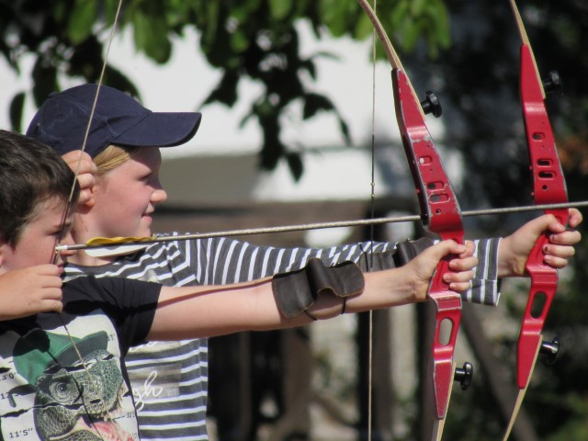
Assessment and Reporting

Assessment
At La Moye School, assessment is an integral part of the teaching and learning process which focuses on what a pupil can or cannot do (diagnostic), what a pupil needs to do next (formative) and assess a pupil’s progress so far (summative). We aim to develop a positive self-image in our pupils through constructive feedback and the feeling of success which encourages further study. Staff use a range of assessment strategies, including:
- Informal observations
- Oral questions and answers
- Verbal feedback
- Marked children’s learning
- Self and peer evaluation
- Formal tests.
- Mini quizzes
- Work scrutiny
- Small group work and interventions

Pupils are very important in this process and are frequently asked to self and peer assess their own work. They are taught the skills needed to do this effectively and purposefully.

Most teacher feedback happens live in lessons, where teachers move around the classroom to give targeted feedback, pause lessons and clarify points live, or call children to work with them in a small ‘focus’ group. This means the amount of written marking in books will be reduced, however, research has shown that this is one of the most effective ways for pupils to improve. Where learning is ‘marked’ after the lesson, it is important for children to act on the improvements as soon as possible.

We ensure pupils are assessed against Jersey and National Standards in the core subjects of English and Mathematics each term. Any judgements made are based on ‘age-related expectations’ for each year group. Teachers also keep records of children’s attainment in other curriculum subjects, and this is formally tracked once a year. Each teacher reviews their pupils’ progress and maintains appropriate records to inform their planning. These records are on-going and identify and describe the progress and achievement of the pupils. They show the attainment of each child as required by the Jersey Curriculum and are based on evidence.

In Year 6, as in all Jersey Schools, our children have taken part in the National Curriculum Tests used in the UK. We believe the tests are a useful way of verifying our teacher assessments. We conduct them in a calm, positive way to reduce undue worry.

Reports
La Moye also reports to parents throughout the year as follows:
- In September each class holds a Curriculum Conversation meeting which parents are invited to. This enables parents to meet their child’s teacher and learn about the class routines, expectations, arrangements, etc.
- Parents are encouraged to attend two consultation evenings, one in the Autumn and one in the Spring to review their child’s social and emotional progress, along with academic progress and attainment. A record of the main points of these meetings is sent home. These are sometimes in person, or online using a live video link.
- A third ‘Celebrating Learning’ event in the Summer term is hosted by the pupils, who lead the discussion with parents and teacher to discuss their own learning and progress.
- A summary written report is sent home in the Summer term.

Special Educational Needs, Disabilities & Wellbeing
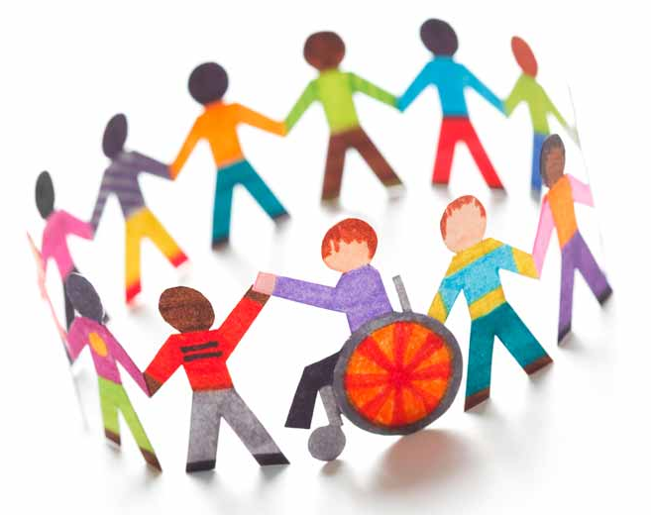
We are an inclusive school. At La Moye School we understand that all pupils are individuals and we provide for a wide variety of pupils with additional needs across the key stages. For most pupils, their needs are able to be met by the class teacher in the classroom environment without any additional support.

Some pupils may need additional support which we can provide for in a number of different ways including individual learning plans; teaching assistant time and intervention programmes. This could be because they have what would be termed ‘Special Educational Needs or Disabilities’. This need could be short term, longer term or something that may impact on the child for the rest of their lives.

Special Educational Needs & Disabilities (SEND) is an extremely broad area and can refer to a wide variety of different needs a child may have. SEND can relate to:
- Learning needs (e.g reading difficulties or working memory issues)
- Social and Communication needs (e.g Speech and Language needs, ADHD or Autism)
- Emotional, behavioural and well-being needs (e.g anxiety, attachment)
- Physical needs (e.g Hearing loss, mobility issues, motor control)

A small number of pupils may have needs which require support from external professionals such as Speech and Language, Occupational Therapists or Educational Psychologists.

How are Special Educational Needs and Disabilities identified?
At La Moye School we aim to identify and support any pupils with special education needs as soon as possible, starting in our Early Years Foundation Stage (Nursery and Reception).

Often the child’s class teacher may notice a child is having difficulties or it may be noticed by a different professional such as a health visitor, or a parent may share a concern with the school. If it seems that your child may have a Special Educational Need or Disability then the class teacher will initially work to find ways to support them. If the class teacher has continued concerns, they will speak to the Special Educational Needs and Disabilities Coordinator (SENDCo) who will determine the next steps. You will be informed if any specific action is taken or if we would like to involve another agency before this happens. Usually your signature will be required on a referral form.

Each term the school has a Planning and Review meeting (PARM) where a wide range of professionals that work with school come together to discuss children that we want to support. In this multi-agency way, we are able to ensure children get the right support as quickly as possible.

How do we support pupils with Special Educational Needs & Disabilites?
La Moye School provides a broad and balanced curriculum for all pupils. Within the classroom, class teachers set suitable learning challenges and respond to pupil’s diverse learning needs through the resources they use, the different teaching styles they adapt and the planning they put in place.

If pupils require additional support to help them overcome their ‘barrier to learning’, they will adapt the arrangements which are personal to the needs of the child at that time and detail targets and provision to be put in place. The school also provides a range of intervention programmes designed to support specific learning needs and wellbeing.

A positive school/parent partnership is crucial in order to support a child with Special Educational Needs and Disabilities and we work closely with all our parents on a regular basis to support their child in achieving their full potential.

English

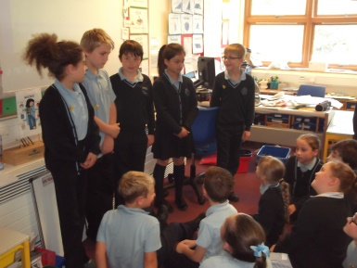
English is a fundamental area of the curriculum. The gradual mastery of it is not restricted to the specific daily lessons, but is further developed and encouraged throughout the curriculum. The three key aspects of the English curriculum; Speaking and listening, Writing and Reading are the foundations of communication. La Moye school recognise that literacy skills are at the heart of all learning as they enable pupils to communicate their understanding and ideas as well as enable access to new learning and information. We aim to foster a lifelong love of reading within our pupils through exposure to and immersion in a range of quality texts for pleasure and information. Following an embedded, systematic approach to phonics, pupils will build on their decoding skills to become fluent and independent readers. At La Moye we aim to develop young writers who can write for a range of purposes and audiences and who will be able to express themselves confidently and coherently through writing. Our overall aim is to develop articulate and effective communicators who will have the skills necessary to succeed in work and life.

Speaking and Listening 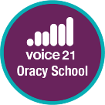
The development of speaking and listening skills is at the heart of the teaching and learning of reading and writing. We aim to teach pupils to communicate effectively and to listen and respond appropriately in different circumstances. We believe that every young person should leave school able to express their ideas, communicate with confidence and speak eloquently. These vital skills are captured by the word ‘oracy’ which was coined in the 1960s to give spoken language parity with literacy and numeracy. Voice 21, the National Oracy Education charity, is working with teachers and schools across Jersey to support the development of oracy in schools.

Over the course of the year, we are looking forward to using more talk to support learning in lessons and creating more opportunities for our young people to be heard beyond the classroom.

If you would like to find out more about oracy or Voice 21 please take a look at their website: www.voice21.org

Phonics

One of the greatest gifts we can give a child is the ability to read fluently, confidently accurately and for pleasure. We believe that reading should be an enjoyable activity and our approach to teaching reading is based on this. We use the synthetic phonics scheme ‘Read Write Inc.’ which starts with our children in Nursery and continues until they are fluent readers. The aim of this scheme is to get children to the fluent stage as soon as possible so they can go on to explore the world of books confidently.

Your child will learn to read in a very simple way. He or she will learn to:
- Read letters by their ‘sounds’ - learning sound-grapheme correspondence so that they are able to read single letter sounds as well as digraphs and trigraphs.
- Blend these sounds to read words
- Read the words in a story
- Read words which are not phonetically regular by recognising the graphemes in words which do not produce the usual sound and then remembering these exceptions known as ‘Red words’.

Pupils will begin by learning Speed Sounds Set 1. Set 1 contains single letter sounds as well as a few early digraphs and trigraphs such as ‘ch’ or ‘sh’. These are taught in a specific order according to how frequently they are used in the English language and in a way that children can begin to blend sounds together to read words before knowing all the Set 1 sounds. Speed Sound Set 2 then introduces more digraphs and trigraphs. At the end of Set 2 children will be introduced to letter names in order for them to discuss the difference between sounds in Set 2 and those they will later learn in Set 3. During Speed Sound Set 3 pupils learn the remaining graphemes used in English and look at how they know which grapheme they need when spelling a word. The programme begins with children reading short ditties before moving through the course of coloured books.

Before you get going, visit www.ruthmiskin.com/parents to practise saying the sounds clearly. The more clearly you say the sounds, the more quickly your child will learn.

Reading
As well as phonics reading children in Key Stage 1 will take part in story sharing sessions and weekly guided reading sessions. They will have levelled reading books to take home. Pupils will also read class texts though a text driven approach to English. In KS2, we are then able to explore longer more complex texts with classes and develop their comprehension skills. Books are sent home on a weekly basis and children are encouraged to share this with someone at home.

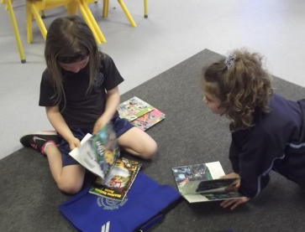
All classes have a library time, when pupils can select a book to take home and spend some time browsing and listening to a recorded story. Thanks to our PTA, our library has recently been revamped and is attractive and well equipped; we have fiction and non-fiction books which pupils can use to support their work in school. Pupils also have the opportunity to read a variety of texts such as leaflets, children’s newspapers, comics, advertisements, notices, signs and labels. Reading is promoted wherever possible. ‘World Book Day’ is celebrated annually; we also have author visits and fun activities to promote enjoyment of reading.

Writing
La Moye School follow a text driven approach to the teaching of writing. This means that pupils are immersed in quality texts which are rich in vocabulary and exemplify the specific aspects of writing which the children are learning. Through the context of our chosen texts pupils build grammar and punctuation skills. They analyse the effect of the choices the author has made in order to be able to emulate this in their own writing. Through deep study of the writing process and break down of their texts pupils begin to develop their own ‘author voice’. Writing lessons are always planned across a learning journey with a specific purposeful outcome at the end.

We acknowledge that without the mechanics of writing being in place pupils will not become fluent and proficient written communicators. Therefore, pupils are taught the necessary grammar, spelling and punctuation skills throughout each learning journey before creating their written outcome. To compliment this we also follow the Read Write Inc Spelling Programme in Year 2-6 which follows on from pupils’ phonic knowledge. Writing learning journeys will cover a vast number of text types, fiction, non-fiction and poetry. They may be based on novels, short story collections, anthologies or picture books. Each half term classes will complete at least two written learning journeys which will often tie to the context of their wider curriculum topics.
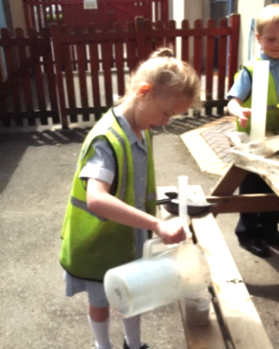
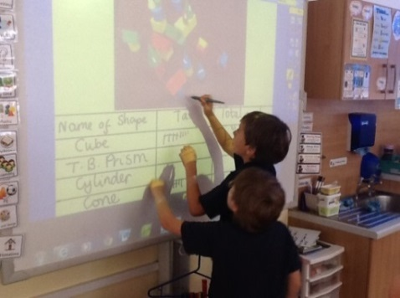
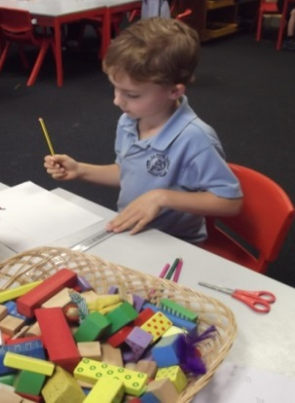

Mathematics

A high-quality mathematics education is about ensuring children are confident, skilled and resilient mathematicians who have the skills to make sense of the world around them.
Throughout our Early Years Foundation Stage, mathematics teaching adheres to the expectations outlined within the Early Years Foundation Stage Framework. We teach children in a ‘mastery’ way and focus on number sense and depth of learning rather than acceleration, ensuring children are secure in their understanding before moving on. This is achieved through group and class work along with ‘continuous provision’ where children can explore their learning in a structured way.
For Years 1 to 6, maths is taught in line with the requirements of the Jersey Curriculum. Again, as maths is a hierarchical subject, we adopt the principle of ‘teaching for mastery’ to ensure the child’s understanding is secure before moving their learning forward.
The Jersey Curriculum for mathematics aims to ensure that all children:
- become fluent in the fundamentals of mathematics, including through varied and frequent practice with increasingly complex problems over time, so that children develop conceptual understanding and the ability to recall and apply knowledge rapidly and accurately.
- reason mathematically by following a line of enquiry, conjecturing relationships and generalisations, and developing an argument, justification or proof using mathematical language.
- can solve problems by applying their mathematics to a variety of routine and non-routine problems with increasing sophistication, including breaking down problems into a series of simpler steps and persevering in seeking solutions.
We cover the full range of mareas specified in the Jersey Curriculum. This includes:
- Number
- Ratio and Proportion
- Algebra
- Measurement
- Geometry
- Statistics
The school follows a structured maths programme from Years 1 to 6 that is based on the principles of gaining fluency and reasoning through hands on learning with equipment, pictorial representations and then abstract thinking (Concrete-Pictorial-Abstract (CPA) Approach).
Mathematics is taught daily as a discrete subject but every effort is made to link maths with other areas of the curriculum. In the Foundation Years, these links are especially evident because of the nature and structure of the planned day
In preparing children for the real world, we are aware of the role that mental maths skills plays and accordingly make every effort to ensure that our children are proficient at these. We teach and practise these skills on a regular basis, often using engaging online resources like Times Table Rockstars and Numbots, which also support home learning.
Our ultimate aim is to ensure our children not only have the mathematical skills needed for later life but also to promote confidence, competence, enjoyment, enthusiasm and a fascination about maths itself through practical activities, exploration and discussion.

P.S.H.E.
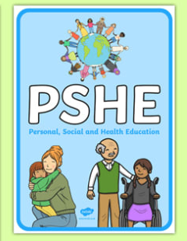
We aim to develop successful learners who have the qualities and attributes they need to manage their lives, fulfil their academic potential and thrive as individuals, family members and members of society, both now and in the future. PSHE education is integral to a planned programme of learning which helps our children to make good progress and to leave us as responsible, happy members of our island community.

Personal, Social and Health Education (PSHE), including citizenship education, contributes to the school curriculum by helping to give pupils the knowledge, skills and understanding they need to become informed, active, responsible citizens.
At La Moye School we follow a structured programme of Personal, Social, Health and Emotional learning. Children will acquire the knowledge, understanding and skills they need to better manage their lives, now and in the future. We aim to ensure that children develop the skills they need to grow up as healthy individuals who can make informed decisions and positive choices. By teaching children to be safe and healthy, and by building self-esteem, resilience and empathy, we tackle barriers to learning, raise aspirations, and improve the life chances of all. Children also find out about the main political and social institutions that affect their lives and about their responsibilities, rights and duties as individuals, and as members of communities. They will learn to understand and respect our common humanity, diversity and differences.
Science
“The important thing is to never stop questioning.”
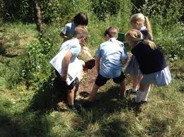
Albert Einsteinenabling children to understand the world around them. Science is primarily about proving or disproving hypotheses by conducting investigations to produce reliable evidence. It requires skills such as reasoning, predicting and explaining. Through stimulating and challenging experiences we provide, children are able to answer scientific questions and secure their knowledge and understanding.

To enable a broad and balanced curriculum to be taught across the school, we have devised a carefully planned scheme of work for science, built around the programmes of study detailed in both the National and Jersey Curriculum. At La Moye, teachers use visits, visitors and ‘hooks’ of interest to bring science to life.

Over the course of the academic year, the statutory guidance of two hours science per week has been allocated across Topic driven units. At times, this will be spread evenly each week, at other times sessions may be grouped, for example through a unit of weeks or a focused day.

There is real emphasis on ‘Working Scientifically’ and on practical and observational investigation skills. Pupils are encouraged to ask as many questions as they can. Enquiry includes: observing over time; pattern seeking; identifying, classifying and grouping; comparative and fair testing (controlled investigations); and researching using secondary sources. Pupils should seek answers to questions through collecting, analysing and presenting data.

Science units are designed so that they build upon prior learning, building on key concepts as pupils progress. We ensure that there are opportunities for children of all abilities to develop their skills and knowledge in each unit and we also build progression into the science scheme of work, so that the children are increasingly challenged as they progress through the school.

La Moye School aims to ensure that all pupils:

- develop scientific knowledge and conceptual understanding through the specific disciplines of biology, chemistry and physics.

- develop understanding of the nature, processes and methods of science through different types of science enquiries that help them to answer scientific questions about the world around them.

- are equipped with the scientific knowledge required to understand the uses and implications of science, today and for the future.
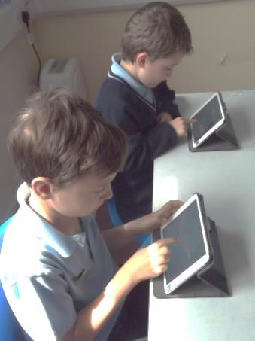
Computing
‘Investing in tomorrow’s technology today is more critical than ever.’
Bill Gates
At La Moye School, we aim to enable children to develop the necessary skills to prepare them for their future in this ever evolving online world. Through implementing an engaging and relevant computing curriculum, we will enhance learning across all subjects. Children will be taught to understand the fundamental principles of computer science by designing, writing and debugging programs. Children will also explore a variety of software and search technologies to further understand their purpose. Safe, respectful and responsible usage of technology underpins computing at La Moye. Computing plays an ever increasing part in our lives. Pupils are often adept, confident and active in today’s digital world. We aim to develop and encourage this digital literacy so that the pupils can use IT to develop ideas and to communicate.

Computing is integrated across and within all subject areas, but is also taught through our new curriculum. There are many programs that enable us to introduce pupils to word processing, data handling, simulations, data logging, spread sheets, control technology at the appropriate levels. During ‘coding’ lessons they will learn to design, write and debug programs, to understand networks and search effectively. They will use many Apps to enhance their learning across the curriculum. We are excited about the innovations our new curriculum is allow us to explore, and are confident that the children’s knowledge and skills will blossom!

In Foundation Stage and Key Stage 1 your child may use Seesaw to view and share learning and communicate electronically with their teacher. In Key Stage 2 your child will use powerful tools like Google Suite to communicate electronically and to complete homework assignments using the Google Classroom app. We also teach children how to communicate with their teachers through Office 365. Having a tablet PC or laptop at home that your child can use for homework is very valuable once your child reaches Key Stage 2. We have a small quantity of loan devices available for families that need support with this.

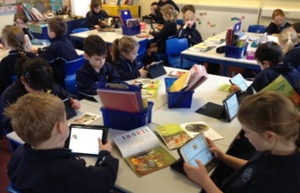
Most importantly, we want our pupils to use Computing responsibly and safely. Regular lessons cover all aspects of online safety in an age appropriate way, using a range of resources. We are often involved in local and national online safety awareness campaigns and share information during themed assemblies, as well as regularly updating parents. The pupils are taught to be aware of risks and how to protect themselves. All members of the school community have to sign up to an ‘Acceptable Use Policy’ and this is reviewed regularly. Pupils in Year 3 and upwards have school email addresses and pupils have access to filtered internet sites. Internet safety is paramount and is closely monitored by both the School and the States of Jersey.

Wider Curriculum
At La Moye school we have developed our own broad and balanced curriculum to allows our pupils to develop a deep knowledge and understanding through all subject areas. Pupils are taught key skills and knowledge through the context of topic units. Our curriculum makes key links to Jersey and allows pupils to make comparisons and links to our unique Island and the rest of the world. Geography, history, science, art and design technology are taught through the context of topic-based units. RE, PSHE, PE, music, French and computing are taught discreetly but with links made to wider topic contexts if appropriate. Through topic based units, the children are immersed in relevant, engaging and exciting themes, key concepts within subject disciplines are carefully woven through our topic units so that pupils build on their knowledge and understanding over time. We have customised these topics to meet the needs of all our groups of learners and provide a broad, rich and deep curriculum that is in line with the Jersey Curriculum.
Geography
“Geography is the subject which holds the key to our future.”
Michael Palin

Geography is motivating and inspiring our children to find out about their world. It is an investigative subject, which develops an understanding of concepts, knowledge and skills. Pupils gain knowledge about diverse places, people, resources and natural and human environments, together with a deep understanding of the Earth’s key physical and human processes. We encourage natural curiosity to create inquisitive learners who look closely at the world around them. Teachers use visits, visitors and ‘hooks’ of interest to bring geography to life. Whenever possible we use our Island as a learning resource and children will learn about the characteristics of Jersey, the other Channel Islands and the surrounding waters.
History
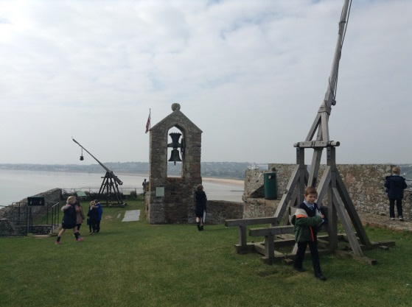
At La Moye School, children undertake a broad and balanced history curriculum that allows them to learn about history in Jersey, Britain and the wider world. Through the teaching of History, we aim to inspire children’s’ curiosity about the past which will enable them to gain a knowledge of:
- Changes within living memory and those beyond
- Significant individuals and significant events both locally, nationally and globally.
- Prehistoric Britain, Ancient Civilisations, Invaders and Settlers along with British history post 1066.
Throughout our history teaching, children develop an awareness of the past using accurate terminology and an understanding of chronology and where people and events fit in relation to each other. Children learn about historical enquiry and how we find out about the past, why things have happened and what were the lasting effects and also how our knowledge of the past is constructed from a range of sources.
Children are encouraged to explore and ask historical questions such as: ‘When did this event happen?’, ‘What caused this event?’ ‘How was life different from today?’ ‘How was it the same?’ to develop their understanding.
Historical artefacts, pictorial evidence, written accounts, drama, role-play, stories and special events are an essential means of children finding out and learning about history. Visits to local heritage sites are valued as they bring history alive and make it more meaningful. Even a walk around the local area is encouraged as it can prove to be a rewarding historical experience while looking for evidence of the past and discovering how things have changed over time.
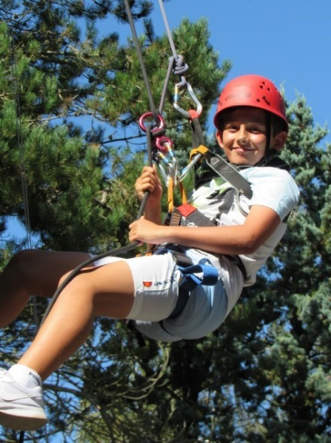
Visits & Visitors
Out of school visits are an essential part of our rich curriculum. We are incredibly fortunate in Jersey to have such a tremendous range of exciting places to visit! We also encourage our pupils to learn from other people and visitors such as authors and local experts, who are regularly invited into school.
This year:
- Year 2 pupils have visited Sark for a day trip as part of their geography learning
- Year 3 have had an overnight stay at Mont Orgueil castle as part of their history learning
- Year 4 pupils had an overnight residential visit to the St. Ouen’s Scout Hut, linked to their science learning.
- Year 5 pupils enjoy a residential visit to Crabbe in St. Mary
- Year 6 will have a two night residential at St. Aubin’s Fort.
We are hopeful that our pre-Covid residential trip to France will be able to return in the near future.
French
“To learn a language is to have one more window from which to look at the world.”
Chinese Proverb
At La Moye, pupils are offered taster sessions in French as early as Nursery and we have ensured continuous French provision through Key Stage 2. Pupils are exposed to songs, nursery rhymes and age appropriate French stories. The emphasis is on fun, with a very visual approach to language learning, through various media.

At Key Stage 2, French is taught for an hour a week by a specialist French teacher. In Year 3 pupils are introduced to the phonic sounds in French, helping them pronounce words for themselves. Songs and story books in Year 3 and 4 are used to give the language a context and a study focus, with performance opportunities. The emphasis is mainly on listening and speaking, with plenty of pair work and interactive activities.

In Years 5 and 6, pupils build on the language structures already taught in lower Key stage 2, as well as learn to talk about themselves and their family and their wider environment. Whilst special emphasis is still placed on listening and speaking, pupils are encouraged to develop their reading and writing skills too. By the end of Year 6 pupils should understand a range of simple questions and be able to engage in conversation about themselves. They should have the ability to ask and answer questions, act out roleplays and deliver presentations in French. Their written work should show increased grammatical awareness and accuracy, and pupils are encouraged to become independent learners through the use of dictionaries.

In Years 5 and 6, pupils are offered the chance to perform in the French Eisteddfod, with notable success in both the song and poem recital classes over the years. La Moye has also played host to visiting French pupils and engaged in penpal writing. As part of our French PenPal program we have been allocated a French school class from Year 3 to 6. We are delighted that our children will now be able to put into practice some of their new language skills in a real world scenario with their French counterparts.

Indeed, our French teacher is also a native Spanish speaker, and so we also have Spanish lessons from time to time too!

Art & Design
“Every child is an Artist.”
~Pablo Picasso~
At La Moye, pupils fully engage in their creativity and focus on the process of Art and Design, not just the product. With an artist’s eye, pupils evaluate the works of local and international artists and draw inspiration for their own pieces.
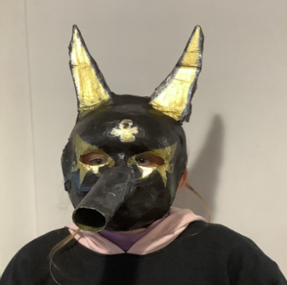
Art, craft and design embody some of the highest forms of human creativity. A high-quality art and design education should engage, inspire and challenge pupils, equipping them with the knowledge and skills to experiment, invent and create their own works of art, craft and design. As pupils at La Moye progress, they will learn to think critically and develop a more rigorous understanding of art and design. They will also discover how art and design reflect and shape our history, and contribute to the culture, creativity and wealth of our Nation.
The Jersey Curriculum for Art and Design aims to ensure that all pupils:
- Produce creative work, exploring their ideas and recording their experiences
- Become proficient in drawing, painting, sculpture and other art, craft and design techniques
- Evaluate and analyse creative works using the language of art, craft and design
- Know about great artists, craft makers and designers, and understand the historical and cultural development of their art forms
- By the end of each key stage, pupils are expected to know, apply and understand the matters, skills and processes specified in the relevant programme of study
In Key Stage 1 pupils are taught to use a range of materials creatively to design and make products. Children will use drawing, painting and sculpture to develop and share their ideas, experiences and imagination. They will develop a wide range of art and design techniques in using colour, pattern, texture, line, shape, form and space. They will also learn about the work of a range of artists, craft makers and designers and compare different practices and disciplines, whilst making links back to their own work.
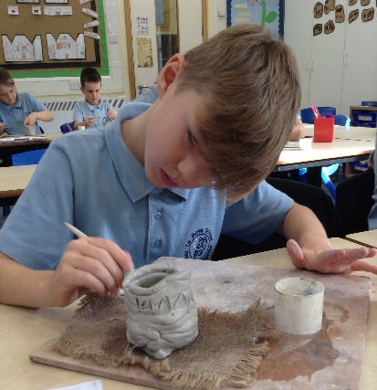
In Key Stage 2 Pupils are taught to develop their techniques, including their control and their use of materials, with creativity, experimentation and an increasing awareness of different kinds of art, craft and design. Pupils are taught to create sketch books to record their observations and use them to review and revisit ideas, to improve their mastery of art and design techniques, including drawing, painting and sculpture with a range of materials (for example, pencil, charcoal, paint, clay). They will develop artist studies and take inspiration from artistic styles to support their own artistic journey.
The pupils are encouraged to fully engage in their learning and focus on the process not just the end product. ‘It is the making that matters!’ The pupils also experience working with local artists and experience a range of trips using the locality as a rich source of inspiration for art projects.

Design & Technology

Design and Technology (D.T.) encourages children to become creative problem solvers, both as individuals and as part of a team. Children will learn how to work creatively, imaginatively and safely with a variety of tools and materials, becoming resourceful, innovative and imaginative problem solvers. A wide range of new skills will be acquired and knowledge from other subjects will be drawn upon and applied. In addition, children will develop the life skills and knowledge associated with healthy living, food nutrition and cookery.

In line with the Jersey Curriculum, our aims for our DT curriculum are:
- To provide opportunities for all children to design and make quality products.
- To provide children with the regular opportunities to explore food and cooking techniques, with a focus on promoting healthy eating and environmental issues within food production.
- To develop design and making skills, knowledge and understanding to the best of each child’s ability; using and selecting a range of tools, materials and components.
- To become creative problem solvers both individually and as members of a team.
- To be able to use computing in conjunction with the designing and making process.
- To develop an ability to criticise constructively, and evaluate their own products and those of others.
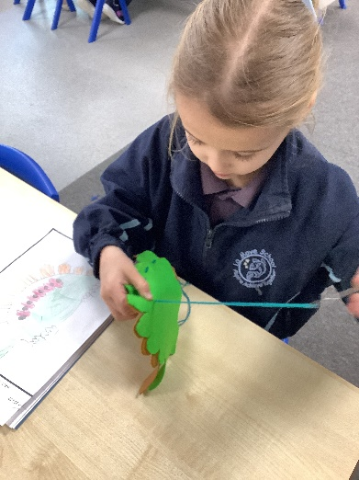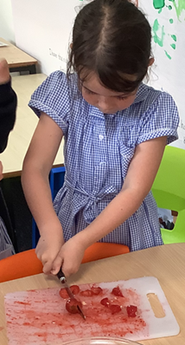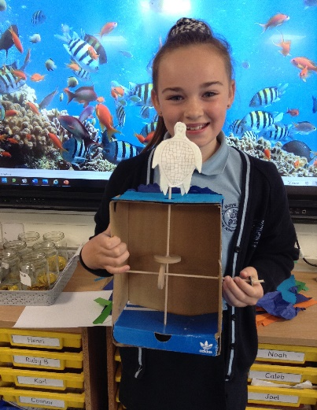
Music
Music is highly regarded at La Moye School and it is used as a vehicle to unite the school in many settings. These include events such as; community concerts, Christmas events, school performances, music clubs/groups and Key Stage singing. We use an online, interactive website to support teaching and delivering the curriculum, called Charanga. This provides an excellent base, covering a wide selection of music from all time periods. This is also linked with our Creative Curriculum units where possible.
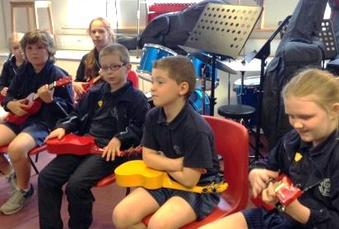
Music is a universal language that embodies one of the highest forms of creativity. A high-quality music education should engage and inspire pupils to develop a love of music and their talent as musicians, and so increase their self-confidence, creativity and sense of achievement. As pupils progress, they should develop a critical engagement with music, allowing them to compose, and to listen with discrimination to the best in the musical canon.
Aims
The Jersey Curriculum for music aims to ensure that all pupils:
- perform, listen to, review and evaluate music across a range of historical periods, genres, styles and traditions, including the works of the great composers and musicians;
- learn to sing and to use their voices, to create and compose music on their own and with others, have the opportunity to learn a musical instrument, use technology appropriately and have the opportunity to progress to the next level of musical excellence;
- understand and explore how music is created, produced and communicated, including through the inter-related dimensions: pitch, duration, dynamics, tempo, timbre, texture, structure and appropriate musical notations.

Key stage 1
Pupils should be taught to:
- use their voices expressively and creatively by singing songs and speaking chants and rhymes;
- play both tuned and untuned instruments musically;
- listen with concentration and understanding to a range of high-quality live and recorded music;
- experiment with, create, select and combine sounds using the inter-related dimensions of music.

Key stage 2
Pupils should be taught to sing and play musically with increasing confidence and control. They should develop an understanding of musical composition, organising and manipulating ideas within musical structures and reproducing sounds from aural memory.
Pupils should be taught to:
- play and perform in solo and ensemble contexts, using their voices and playing musical instruments with increasing accuracy, fluency, control and expression;
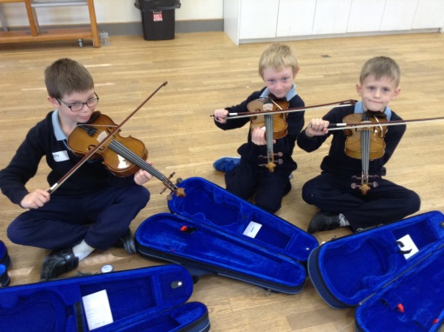
- improvise and compose music for a range of purposes using the inter-related dimensions of music;
- listen with attention to detail and recall sounds with increasing aural memory;
- use and understand staff and other musical notations;
- appreciate and understand a wide range of high-quality live and recorded music drawn from different traditions and from great composers and musicians;
- develop an understanding of the history of music.

We employ specialist music teachers at La Moye to provide expert teaching for individuals and groups to play many instruments. These include strings, woodwind and percussion. We have a highly acclaimed choir that perform in a variety of settings throughout Jersey. Musical performances are enjoyed and appreciated by participants as well as audiences.

Physical Education (P.E.)
Each class is allocated two hours per week for Physical Education; one indoor and one outdoor session. This is supplemented by a range of after school sports clubs and coaches. Pupils are encouraged to work at their own level, in a safe but challenging environment. The school also has a long history of fielding school teams in various sports such as football, netball, tag rugby, cricket and athletics. The emphasis is on developing a team spirit and enjoyment of the game itself although success is good too and should be celebrated!
Our PE curriculum is designed to provide every child with the opportunity to reach their physical, social and emotional potential. It allows them to discover the capabilities of their bodies, develop an in depth understanding of how their body can change, and build a repertoire of skills to aid them throughout their lives.
As a school we have recently invested in real PE, a scheme of work that we felt matched our vision and the needs of our children perfectly. It focuses on 6 key areas that we feel are essential in the development of children as they grow and learn. The key areas are shown below, each with an overview of what we aim to provide each child with as a result of outstanding physical education:
Physical
- For all children to be able to effectively transfer skills and movements across a range of activities. For all children to perform a variety of skills consistently and effectively in challenging or competitive situations.
Health & Fitness
- For all children to be able to explain how individuals need different types and levels of fitness to be more effective in their activity/ role/ event. For all children to be able to plan and follow their own basic fitness programme. For all children to be able to explain the basic fitness components and to know how long to exercise to keep healthy.
Creative
- For all children to be able to use variety and creativity to engage an audience. For all children to be able to respond imaginatively to different situations, adapting and adjusting skills, movements or tactics.
Cognitive
- For all children to be able to review, analyse and evaluate their own and others' strengths and weaknesses. For all children to be able to read and react to different game situations as they develop.

Social
- For all children to be able to involve others and motivate people around them to perform. For all children to be able to give and receive sensitive feedback to improve their own and others' performance.
Personal
- For all children to be able to create their own learning journey and revise it when needed. For all children to be able to see all new challenges as opportunities to learn and develop.
Supplementary activities – To compliment the above activities and to expose the pupils to a wide range of sporting activities, the school invites coaches and development officers to lead lessons across all year groups in their area of expertise. This includes football, Swimming, tag-rugby, cricket, fencing, golf, Gaelic football, dance and tennis.

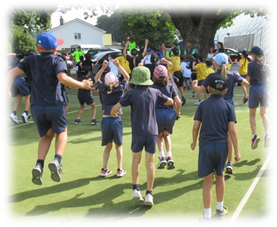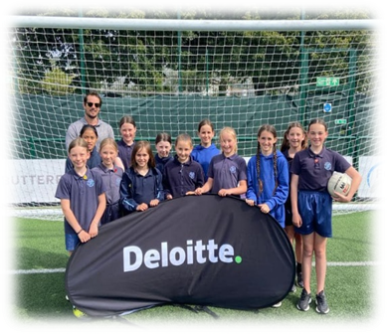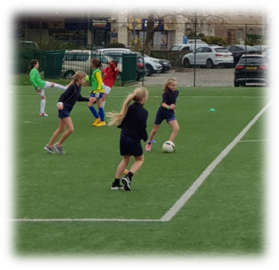

Religious Education
The principal aim of religious education is to explore what people believe and what difference this makes to how they live, so that pupils can gain the knowledge, understanding and skills needed to handle questions raised by religion and belief, reflecting on their own ideas and ways of living.
Our La Moye RE curriculum aligns and supports our Core Values and our commitment to uphold the values of our Rights and Respecting community. Our RE curriculum promotes spiritual, moral, social, and cultural development and helps our young people work out how to live a good life. Our RE curriculum enables our pupils to flourish as citizens in a pluralistic and global community.

The Jersey curriculum for RE aims to ensure that all pupils:
1. make sense of a range of religious and non-religious beliefs, so that they can:
• identify, describe, explain and analyse beliefs and concepts in the context of living religions, using appropriate vocabulary
• explain how and why these beliefs are understood in different ways, by individuals and within communities
• recognise how and why sources of authority (e.g., texts, teachings, traditions, leaders) are used, expressed and interpreted in different ways, developing skills of interpretation
2. understand the impact and significance of religious and non-religious beliefs, so that they can:
• examine and explain how and why people express their beliefs in diverse ways
• recognise and account for ways in which people put their beliefs into action in diverse ways, in their everyday lives, within their communities and in the wider world
• appreciate and appraise the significance of different ways of life and ways of expressing meaning
3. make connections between religious and non-religious beliefs, concepts, practices and ideas studied, so that they can:
• evaluate, reflect on and enquire into key concepts and questions studied, responding thoughtfully and creatively, giving good reasons for their responses
• challenge the ideas studied, and allow the ideas studied to challenge their own thinking, articulating beliefs, values and commitments clearly in response
• discern possible connections between the ideas studied and their own ways of understanding the world, expressing their critical responses and personal reflections with increasing clarity and understanding.

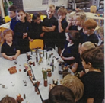
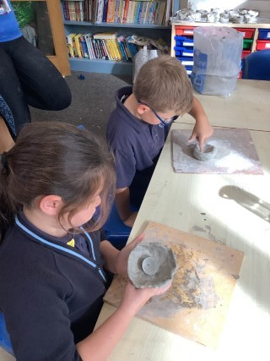
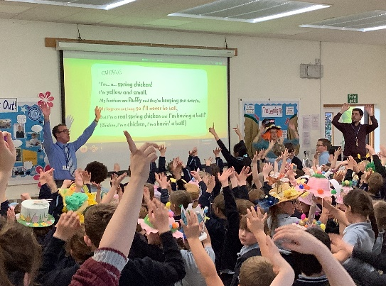

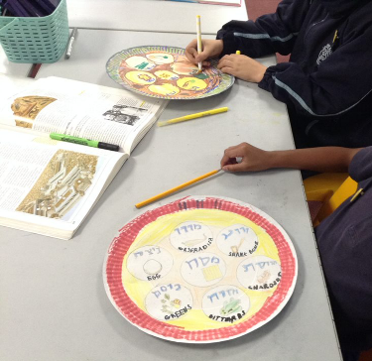
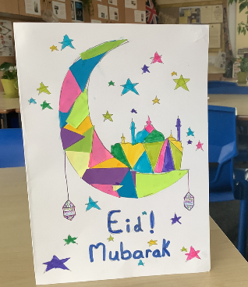
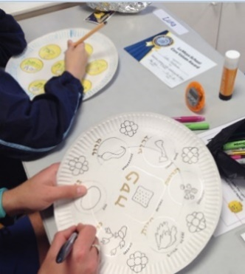
￼

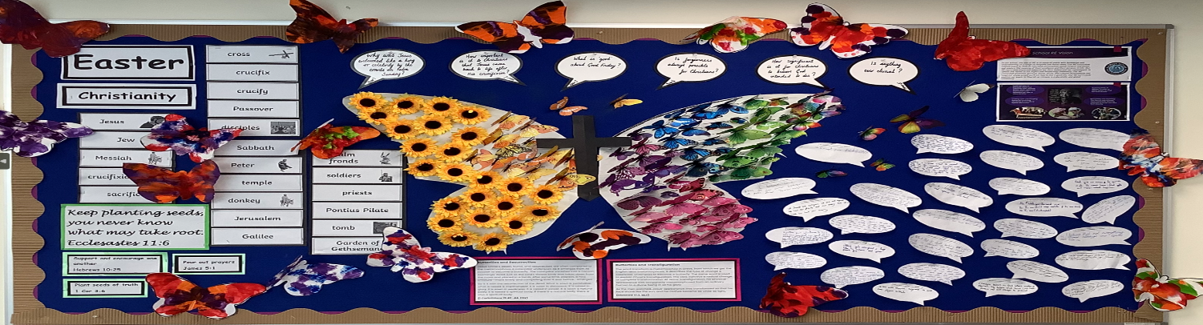

Collective Worship & Spiritual, Moral, Social and
Cultural Education (SMSC)
Our collective worship assemblies include spiritual, moral, social, cultural and religious themes and are led by members of staff or visiting speakers. They include beliefs that are ‘broadly Christian’ yet common to other major world faiths include:- God, justice, love, peace, good, bad, greed, poverty, pollution, morality, tolerance, co-operation, selfishness, war and prejudice.

Values we feel are important to our School community include: respect, trust, fairness, understanding, tolerance, appreciation, responsibility, caring, co-operation, patience, peace, honesty, courage, freedom, quality, friendship, humility, happiness and thoughtfulness.

Through themes such as these the spiritual awareness of every individual may be developed. We offer pupils opportunities to explore and share beliefs, to consider the relevance of ideas, beliefs and values to their own lives and to think about the needs of others and what it means to be part of a community. Collective worship offers an opportunity to re-affirm, interpret and put into practice the core values of the School. It provides a time to celebrate the various achievements of members of the community that are held to be of worth. A parent has the right to withdraw their child from religious education, acts of worship or assemblies of a religious nature.

www.lamoyeschool.co.uk
Facebook: La Moye School

