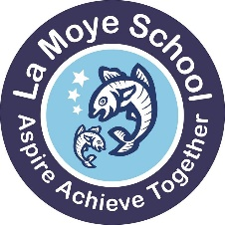
La Moye Primary School
La Route Orange Telephone: (01534) 741390 Headteacher: Mr. John Baudains
St. Brelade, Jersey, JE3 8GQ Email: admin@lamoye.sch.je Deputy Headteacher: Mr. Lawrence Gibaut
Website: www.lamoye.sch.je Fax: (01534) 499635

19th April 2024
Dear Children, Parents and Staff,

La Moye Woodland Redevelopment Design Competition
As we talked about in our assembly on Tuesday, ASHBE construction, who are building the Melrose development adjacent to the school are going to be helping us, from their % for the Arts contribution, to redevelop our woodland areas. This will give us a significant amount of money, £60,000 in fact, towards this project. This this feels like a ‘once in a generation’ opportunity to improve these areas, and so we are really excited about what we could do with this money.

The designers helping to develop the project, Chris Clifford and Siobhann MacLeod, came along to assembly on Tuesday and worked with the staff during InSet day on Monday, and also talked through ideas with our Eco Team. Siobhann shared some of her initial ideas and designs, but emphasised that she is eager to gather the thoughts and ideas of as many children as possible so that the finished design is what our children and staff want and need, and adds real value to our school. This is a plan of her initial ideas, with more details at the end of the letter. We have uploaded the design onto our website here so you can see it more easily:

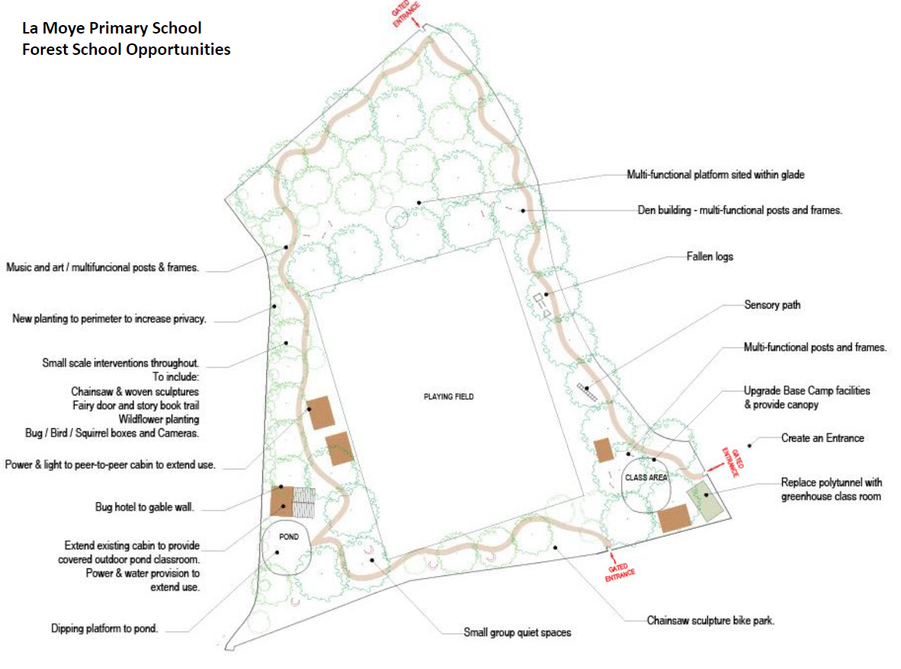

Our ambition is to ensure our redeveloped woodland has opportunities for:
- Outdoor learning (like science, design and technology, art, story-telling…)
- Forest School (making our Forest School the envy of every other school!)
- Environmental learning (like growing, learning about wildlife, learning about ecology)
- Outdoor and Adventurous learning (like orienteering, den building, sensory paths, a running path)
- Mental Health and Wellbeing (so quiet spaces for reflection and thinking, Peer Mediation, yoga)

We are sending out the outline map of the field on a separate page. You could:
- Cut this out and stick it on a larger A3 sheet to produce your own design.
- Not use the map, but draw your own pictures- this would be fine too. Remember to write labels for what you want so this is clear.
- Find pictures online and print them out, or take some of real areas in Jersey you want to copy, and add them into your design.

Your design must:
- Be no bigger than A3 (because we want to display lots of them!)
- Use mainly natural materials- be mostly plastic free!
- Have ideas/areas that can be used in lots of different ways
- Attract wildlife, including insects, and have more plants so we can learn about them
- Have ideas for young children and also older children
- Have learning spaces as well as play spaces
- Include the pond and wooden chalets that we already have
- Be exciting and imaginative!

Your design must not:
- Need trees to be cut down
- Not have any parts that are really expensive or too complicated

Designs need to be handed in to your class teacher by Friday 10th May. The Eco Team and our Eco Teacher, Miss Carter, Miss Ward and Miss Foott (our Forest School teachers) and Chris and Siobhann will help us to choose the winning designs. Siobhann will try to use some of the features in the finished design. There will be prizes for the winners!

We are looking forward to some very exciting designs! We hope lots of people will get designing! More ideas follow…

Yours sincerely,


Mr. J. Baudains
Headteacher

More ideas from Siobhann:


