
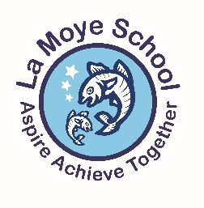
Year 5 Spring 1 Newsletter

Welcome back to the Spring Term and 2024. We hope you all had a wonderful Christmas and New Year with your families.
We would like to take this opportunity to thank you all for your kind cards and gifts at Christmas time, they were greatly appreciated by all.
We have a busy and exciting half-term planned now that the children are comfortable with the Year 5 routine and expectations.

During the colder and wetter months it is important that your child comes to school everyday with a warm, waterproof coat with a hood that is clearly named. It is also important that children wear the appropriate school shoes with their school uniform – trainers are only to be worn on PE days. If your child cycles to school and wears trainers to do this, please ensure that they bring their school shoes to change into upon arrival at school.
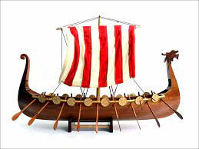
Can we please ask that students have the necessary equipment for lessons: one pencil case with the usual range of writing and recording materials, including a pencil and black pen, coloured pencils, a rubber, a sharpener and a ruler.
Topic Vikings
Through our lessons our learning will focus on the following…
History – Understand the chronology of the Viking era. How do we know what information about the past to trust? What do the sources tell us about Viking life and are they reliable. Make comparisons between different times in the past and learn about different aspects of Viking life -food, trade, games, ships, homes. Viking beliefs surrounding afterlife and burial rituals compared to those of Ancient Egyptians. Look at the Jersey timeline and pinpoint when the Viking Era was in relation to other key events. Explain that Jersey has a distinct Viking heritage.

Geography – We will explore where Vikings came from, where they went and use our understanding of geography to reason why they may have done this. Identify key places such as York (Jorvik), The Isle of man (Tynwald) and explain their significance. Look at a map of Anglo-saxon kingdoms and compare to a map of modern counties. Use them to find key locations and symbols. Find out if the Vikings landed in St.Brelade today what would they find in given locations.

DT – Children will be working towards creating a seasonal dish to enjoy as a class. We hope to take the children on a trip to purchase seasonal produce for them to understand the entire process. They will plan, prepare and make seasonal dishes in small groups. They will learn about the importance of a healthy balanced diet as well as finding out about which crops grow at the different times of year. Children will then develop key cooking skills to be able to create their delicious lunch.

Science – Children will, compare and group together everyday materials on the basis of their properties. They will find out that some materials will dissolve in liquid to form a solution. They will use their knowledge of solids, liquids and gases to decide how mixtures might be separated. They will need to explain that some changes result in the formation of new materials, and that this kind of change is not usually reversible. Children will need to give reasons, based on evidence from comparative and fair tests and find out which materials conduct heat? They will plan different types of scientific enquiries to answer questions, including recognising and controlling variables where necessary - do all solids dissolve?
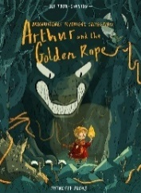
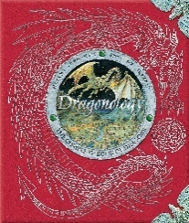
English - In writing, we will be focusing on the following two texts:
Arthur and the Golden Rope – A fantastic story about a bookish young adventurer who must find the courage to save his village and defeat the mighty beast Fenrir! The children will use this book to inspire their own narrative involving a key artefact, such as The Hand of Time, which serves as a tool to develop their stories plot.
Dragonology – a lavishly illustrated reproduction of a legendary volume by the world’s most distinguished dragonologist. The children will study and explore this book before writing their own non-fiction text about dragons.
During Guided Reading, we will be reading Michael Morpurgo’s Kensuke’s Kingdom.
Maths – This term we will be completing units on Fractions, Multiplication, Division, Area and Perimeter and Statistics. We will be using the White Rose materials to support our learning as well as a range of teaching and learning strategies.
For the children to work successfully through fractions, decimals and percentages it is vital that they have a secure grasp of their times tables and division facts. This should continue to be practised frequently in whatever method works for your child. Using Times Table Rockstars on a regular basis allows them this time to practise. We also recommend using this game as a means to revise: https://www.topmarks.co.uk/maths-games/hit-the-button The children will be bringing home weekly paper times tables practice.
P.E. days are on Monday and Friday.
For our Indoor PE session on Mondays, children will be practicing and developing core PE skills in Real PE. In these sessions there will be a focus on the development of agility, balance and coordination, healthy competition, and cooperative learning.

On Friday afternoons, the children will be developing their hockey skills.

RE - Key question for this enquiry: Are Sikh stories important today? Learning Objectives: We are learning about Sikhs and their different beliefs, as well as the meanings that these have to a range of people.
PSHE (Personal, Social, Health, Education) - Our focus this term is ‘Dreams and Goals.’ We will cover: I can identify what I’d like my life to be like when I grow up, I can appreciate the contributions made my different people in different jobs, I appreciate the opportunities that learning and education are giving me, I understand why I am motivated to make a positive contribution to supporting others.
Music - In music this half term we will be continuing to follow the ‘Charanga’ scheme and will be focussing on modern music. Children will be learning the famous Adele song Make You Feel My Love.
Homework – This term we are going to be sending home weekly times tables and spellings in a yellow data folder. The children have had homework set on Google Classroom since September but sadly, not many children have been completing it. By having a paper copy, we are hoping more children engage as it will benefit them to complete it.
Diary Dates:
17th January | Helen Otterwell from Jersey Heritage Viking Workshop
19th January | Charity Market Fair
Friday 9th February @9am | Year 5A Class Assembly in the hall – all 5A parents invited
Monday 12th – Friday 16th February | Half Term
Thursday 7th March | World Book Day
Friday 15th March | Red Nose Day
Wednesday 27th March | Last Day of Term
TBC | Possible trip to Haute Vallee School for a ‘taste of Secondary School life’.

Useful Websites
Maths - https://nrich.maths.org/ https://completemaths.com/
Spelling - https://www.spellingshed.com/en-gb/index.html
Topic - https://www.bbc.co.uk/bitesize/topics/ztyr9j6
https://www.bbc.co.uk/bitesize/topics/ztyr9j6/resources/1
https://www.bbc.co.uk/teach/school-radio/english-ks1-english-viking-sagas/zkyqd6f

We look forward to a busy and enjoyable half of the Spring Term.

Thank you for your continued support.

Mrs Reed and Mrs Sohna

