
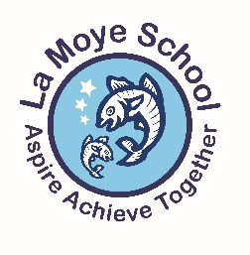
Nursery Spring 1 Newsletter

Dear Parents/Carers,
Welcome back! We hope you all had a lovely Christmas break. Once again, a huge thank you from all the Nursery Team for all our wonderful Christmas gifts, your generosity was very much appreciated. We are all looking forward to another busy half term!
RWI Phonics & Literacy
This half term, we will begin the Read, Write, Inc Phonics scheme in Nursery. All children will access a 15 minute RWI Speed Sound lesson every day. During this session children will be taught to say the sounds of letters with the help of mnemonics. The children will also be introduced to ‘Fred’ who is a RWI character who can only speak in individual sounds! ‘Fred Talk’ is an activity that occurs in every Speed Sound lesson and helps children form the foundations for reading and spelling.

Please practise recognising and saying the pure sounds at home and repeating the mnemonics. The website below has lots of excellent videos for parents.
Website address: www.ruthmiskin.com/en/find-out-more/parents/
We will now begin to ask children to copy/write their names in the morning instead of tracing them. Please encourage and support them with this and also continue to focus on name writing at home.
In Nursery, we will also be focusing on recognising environmental print this half term. We will be doing this by looking for and identifying certain logos and print on everyday products.
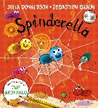
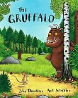
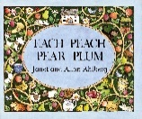
We will be continuing the Hampshire ‘Text Drivers’ approach this term. This will involve focusing on a high quality book and using it to develop speaking and listening skills while encouraging a passion for books and reading. The books we will be focusing on this half term are: The Gruffalo, Each Peach Pear Plum and Spinderella.

The statements the children are being expected to achieve this term are:
- Is able to retell simple stories.
- Recognises familiar signs and labels, and their own name.
- Plays with rhyming words, alliteration and hears and says some letter sounds.
- Recognises and writes some letters from their own name.
- Ascribes meaning to the marks they make.
Maths
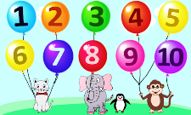
During this half term, will be continuing to practise subitising, counting skills and number recognition to 10. We will be doing this mainly through play along with a short, daily carpet session. We will also be beginning to name simple shapes and using everyday vocabulary for size, weight, capacity and time during play opportunities.
The statements the children are being expected to achieve this half term are:
- Counts with 1:1 correspondence a set of up to 10 objects and begin to recognise numerals 0-10.
- Explores using a range of their own marks and signs which they ascribe mathematical meanings.
- Subitises one, two and three objects (without counting).
- Names simple geometric shapes in their construction and block play.
- Responds to and uses language of position and direction.
Topic
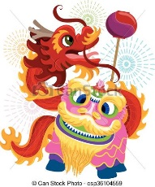
This half term, we will be talking about Chinese New Year, Valentine’s Day and Pancake Day. For Chinese New Year, as a class the children will be making a paper plate dragon and will have the opportunity to try some Chinese food! Children will also be able to participate in other Chinese inspired activities.
The statements the children are being expected to achieve this half term are:
- Understands that different people perform different roles.
- Knows about festivals and celebrations that are marked within their own culture.
- Talks about similarities and differences between themselves and others and among families’ communities and traditions.
PSHE
We will be continuing with our PSHE scheme, Jigsaw. Jigsaw PSHE integrates emotional literacy, self-regulation of behaviour, social skills and spiritual development in a 1 session per week programme.
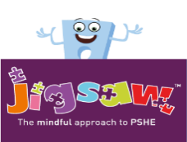
Sessions are structured to include a short input using a variety of learning approaches, appropriate for Nursery children with a selection of activities.
This half term, the focus for our Jigsaw sessions is “Dreams and Goals”.
Dates for you diaries!
16th January - Supersmiles – please ensure consent forms are returned before this!
9th (10th) February – Chinese New Year
12th – 16th February – Half Term
13th February – Pancake Day
Useful Website
Busythings - https://www.busythings.co.uk/
Early Years – Nursery.
Login: home8972
Password: crazy8362

Reminders
- £60 snack money for the Spring Term is now due. This can be paid by cash, ParentPay or cheque made payable to La Moye School Nursery. Many thanks. The final snack payment will be for the Summer Term - £60 due on 16th April.
- We’d be grateful for any materials to keep our junk modelling area fully stocked! Toilet/kitchen roll tubes, egg boxes and any small cardboard boxes (children’s snacks, cosmetics, tea/coffee boxes) are perfect – thank you in advance.
- Please can we ask for toys not to be brought in to school from home. It can be very upsetting if a toy from home is lost or broken.
- A reminder that we are a nut free school and no nuts are to be in lunchboxes please – this includes peanut butter and fruit and nut bars/snacks.
- PE days will continue to be on Tuesday and Friday this half term. We are very lucky to be welcoming back the Sports Bug team to run our Tuesday P.E sessions this half term.
- We hope that you have all managed to log on and access your child’s Tapestry Learning Journey. Please add photographs from home, the children love sharing what they have been up to outside of school! Please see me if you have any issues accessing Tapestry.
- Please remember to always have spare clean clothes for your child in school at all times.
- The weekly snack menu will be on the door for your information.
- We have an Open Door Policy and we can always find time to answer any questions or queries in the mornings/afternoons but please do not hesitate to contact me via email if you’d prefer.
g.stas@lamoye.sch.je
Many thanks,
Mrs Stas.

