Learning objective: To sound out words and form letters correctly

Use the comic strip to find the words and copy them onto the lines.
____________________
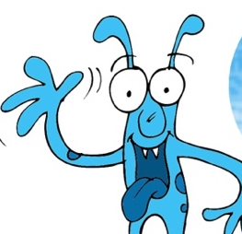  ____________________ | 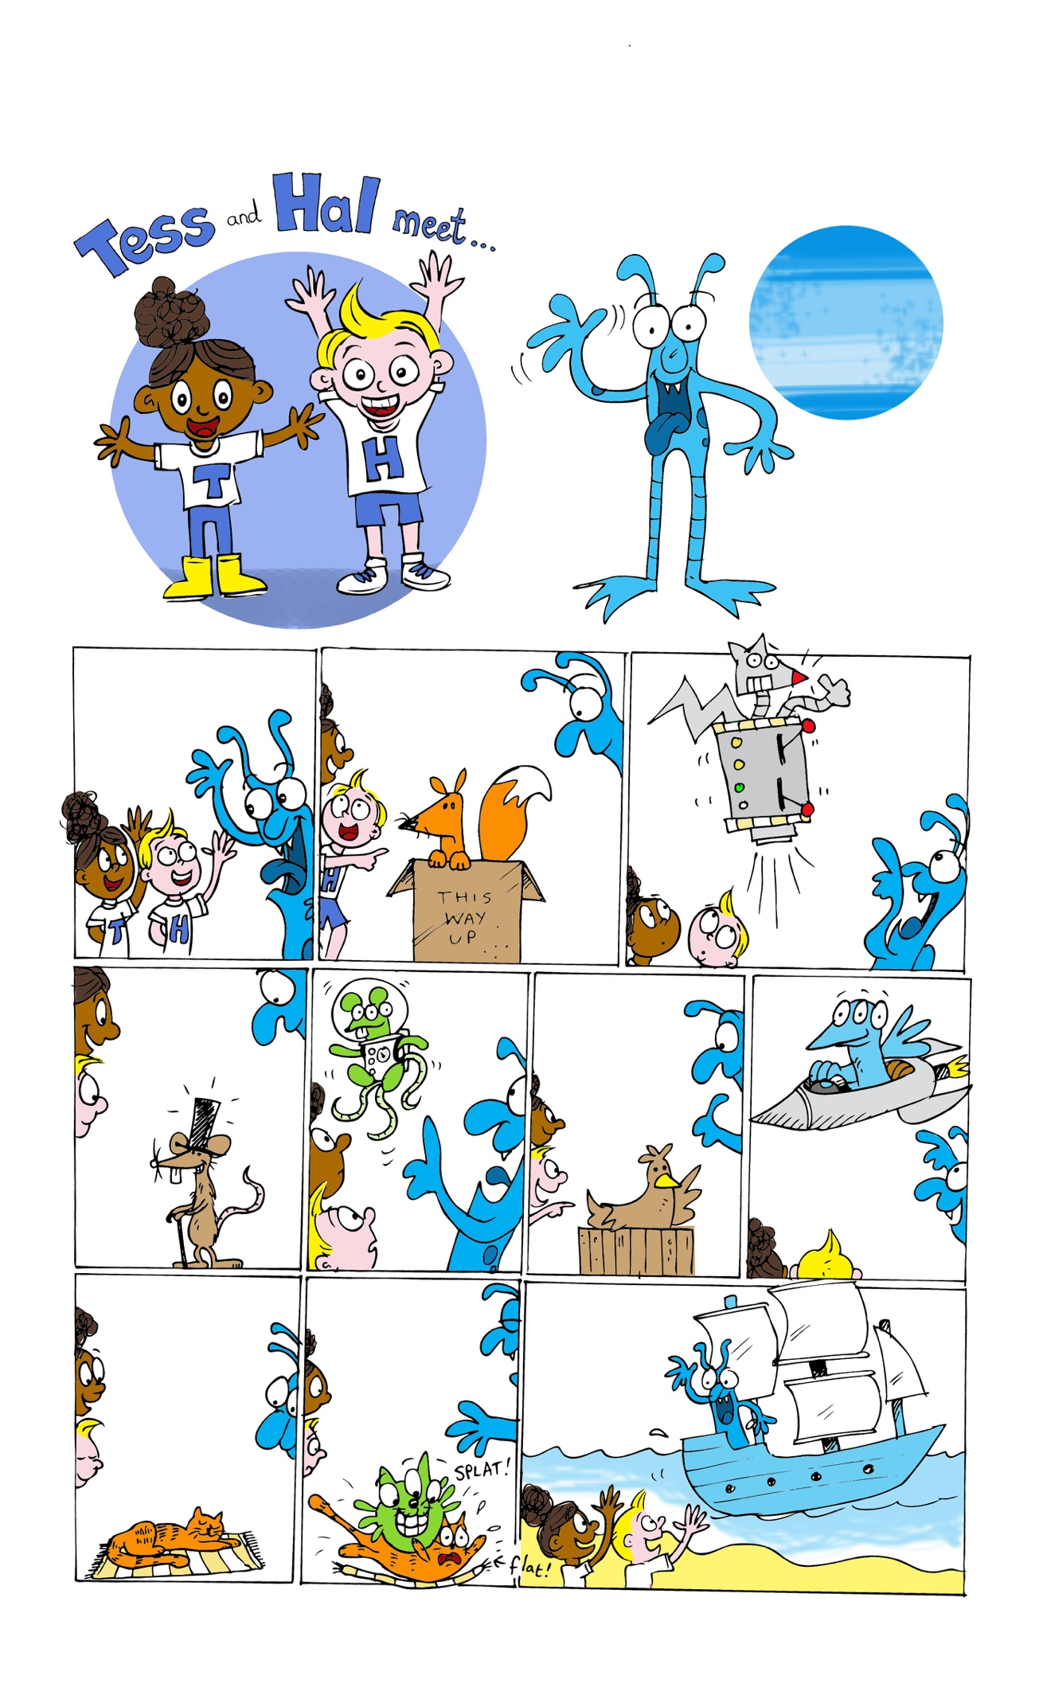  ____________________
____________________ | ____________________
 | ____________________
____________________  ____________________ | 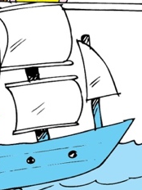

Now can you use ‘fox’ in a sentence?

___________________________________________________________________________
___________________________________________________________________________

Can you use ‘ship’ in a sentence?
___________________________________________________________________________
___________________________________________________________________________

