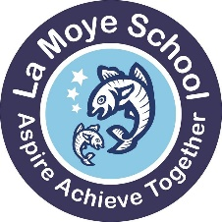
La Moye Primary School
La Route Orange Telephone: (01534) 741390 Headteacher: Mr. John Baudains
St. Brelade, Jersey, JE3 8GQ Email: admin@lamoye.sch.je Deputy Headteacher: Mr. Lawrence Gibaut
Website: www.lamoye.sch.je Fax: (01534) 499635

20.1.22

Dear Parents/Carers,

Communication in Different Languages – Survey.

At La Moye we are fully committed to being as inclusive as possible. As such, we would like to explore how we can best provide home/school communication, both spoken and written, in languages other than English. To help us, could we ask for you to complete and return the below slips. This information will enable us to best support in the languages requested. If you have any questions about the below, please do not hesitate to ask.

Kind regards
Yours faithfully

Lawrence Gibaut
Deputy Head

……………………………………………………………………………………………………………………………………………………………………………
In spoken meetings either virtual, by telephone or face to face it would be helpful if….
spoken communication was in English.

spoken communication was in Polish

spoken communication was in Portuguese

spoken communication was in ……………. (insert name of language)

In written communications it would be helpful if …..
written communication was in English

written communication was in Polish
written communication was in …………….. (insert name of language)
written communication was in Portuguese

Name of child ……………………………………………. Class …………

