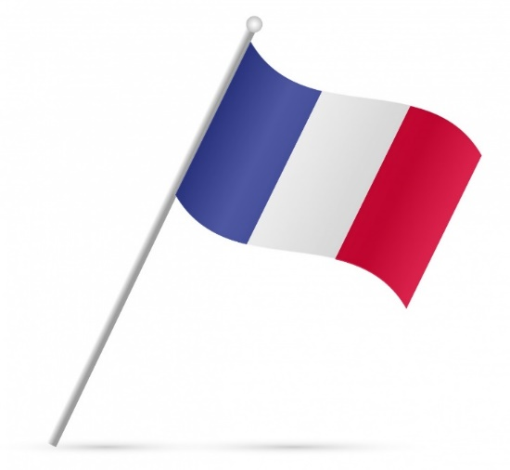
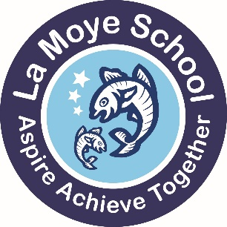
Dear parent/guardian,

As part of our French Pen Pal program, the students share letters with each other, but it is also helpful if the students can see a picture/video of who they are corresponding with.
To that end, we seek your permission to share a picture or video of your child with the French school your child’s class is paired with. The video would be of the children saying their name one after the other on camera, e.g Je m’appelle ….. The photo would be named.
We appreciate this is not something we usually do (name and image together), for data protection reasons, but we think this is a really exciting opportunity for the children to converse in French with a penpal. The video would be live on the school’s private YouTube channel for a month only in order for the French school to show the pupils in the relevant class, and deleted after this.
The link will only be shared with the French school, and they will be reminded to only share it in the classroom with the children. They will be asked not to share with parents or other people. It will not appear on YouTube more generally.
Due to the unusual nature of this, we need your permission to complete this, please reply through the online form.
Any children whose parents do not agree will not be included in the video.
If you do wish to talk to me about any aspect of this Pen Pal experience, please do no hesitate to contact me.
Kind regards,
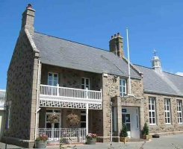
L. N. López
Teacher of MFL
La Moye school
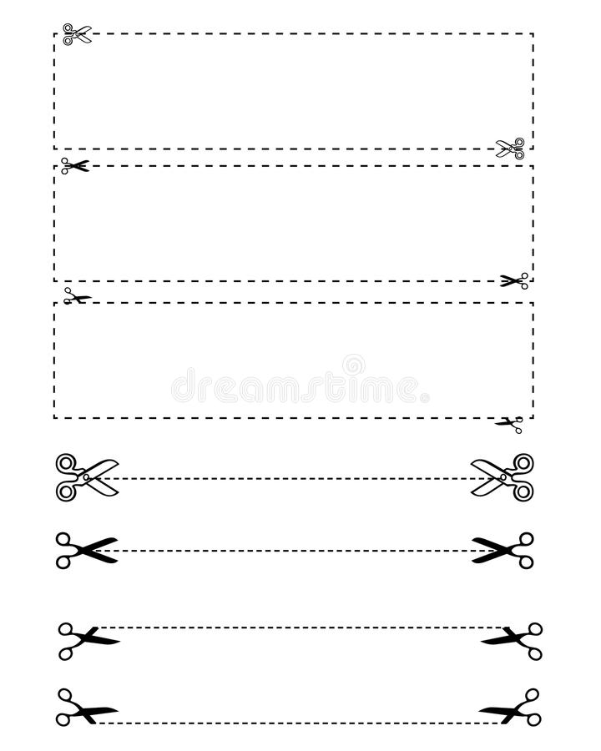
l.lopez@lamoye.sch.je

____________________________________________________________________________________________________

I, the parent or guardian of ____________________ in class ___________________
Please tick one:
I do not consent to the sharing of images or videos of my child in the French Pen Pal program.
I do consent to the sharing of images or videos of my child in the French Pen Pal program.

Name: ______________________ Signed:

